|  |
| --- |
|  |
| ONR Project assessment report  PR-01759 – GB/1648C/B(M): Approval of modification NPA 1-26-157 correction to flask activity release calculation |

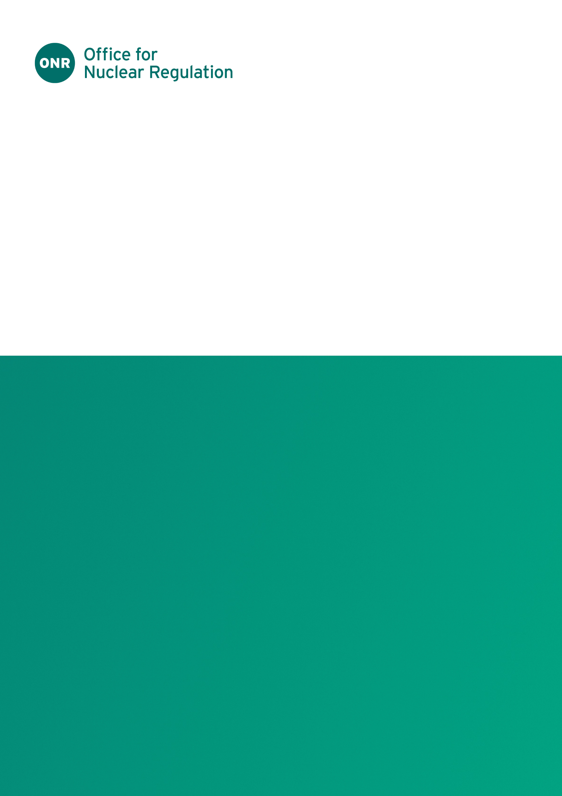

ONR Project assessment report

**Project name**: PR-01759

**Report title**: GB/1648C/B(M): Approval of modification NPA 1-26-157 correction to flask activity release calculation

**Dutyholder/Applicant**: International Nuclear Services Ltd (trading as Nuclear Transport Solutions)

**Authored by**:

**Report issue no**.: 1

**Publication date**:

**Document ID**: ONRW-2019369590-17821

Circulation list (latest issue)

|  |  |  |
| --- | --- | --- |
| Organisation | Recipient | Date report sent |
| ONR |  |  |
| International Nuclear Services Ltd |  |  |

© Office for Nuclear Regulation, [2025]

For published documents, the electronic copy on the ONR website remains the most current publicly available version and copying or printing renders this document uncontrolled. If you wish to reuse this information visit [www.onr.org.uk/copyright](http://www.onr.org.uk/copyright) for details.

# Executive summary

This report presents the findings of the ONR assessment of the proposed modification to correct the calculations undertaken to demonstrate the containment system retention of radioactive contents under a reduction in ambient pressure.

ONR granted a combined package design and shipment approval for the 1648C package, to International Nuclear Services Ltd on 24 June 2022.

The modification constitutes a change to the underpinning pressure calculations to demonstrate that the containment system can retain its radioactive contents under a reduction of ambient pressure to 60 kPa (0.6 bar) in line with paragraph 645 of SSR-6 2018 (ADR 6.4.7.11).

Based on the work carried out by ONR, it is concluded that the proposed modification does not materially affect the original claims, arguments and evidence provided in support of the package design approved in GB/1648C/B(M)T (Rev.10).

It is recommended that ONR’s Head of Regulation for the GB Transport Competent Authority should grant approval by signing the competent authority approval section of modification NPA 1-26-157 subject to the inclusion of the following conditions of approval:

* The package design safety report must be updated to incorporate the corrected calculations.
* The applicant must submit a request for renewal of the package design approval based on the revised package design safety report.

Table 1: List of abbreviations.

|  |  |
| --- | --- |
|  |  |
| ACB | Active Collection Bureau Ltd |
| ADR | Agreement Concerning the International Carriage of Dangerous Goods by Road |
| CoA | Certificate of approval |
| E&Z | Eckert and Ziegler Environmental Services Ltd |
| GB | Great Britain |
| IAEA | The International Atomic Energy Agency |
| INS | International Nuclear Services Ltd |
| NTS | Nuclear Transport Solutions |
| ONR | Office for Nuclear Regulation |
| PDSR | Package Design Safety Report |
| SL | Sellafield Ltd |
| SSR-6 | Regulations for the Safe Transport of Radioactive Material (2018 Edition) |
| UK | United Kingdom |

Table of contents

Executive summary 3

1. Permission requested 6

2. Background 6

3. Assessment and inspection work carried out by ONR in consideration of this request 7

4. Matters arising from ONR’s work 7

5. Conclusions 7

6. Recommendations 8

References 9

# Permission requested

1. In June 2024, International Nuclear Services Ltd (INS) applied for competent authority approval of a Category B modification to the Transport Flask - Package Design No. 1648C (GB/1648C) (ref. [1]). The modification provides a correction to the calculations undertaken to demonstrate the containment system retention of radioactive contents under a reduction in ambient pressure.

# Background

1. We granted a combined package design and shipment approval for the 1648C package, to International Nuclear Services Ltd (INS) on 24 June 2022 (ref. [2]).
2. In parallel to the applicant’s submission for approval of this modification an additional modification, NPA 1-26-156 (ref. [3]), was submitted for competent authority approval and a justification for continued operation (JCO) of the 1648C package design (ref. [4]) for 6 months whilst we assessed the submissions.
3. Our assessment of the JCO concluded that the consignors and carrier were not compliant with all aspects of the current package design and associated shipment approval (ref. [5]). Consequently, the applicant was advised that the extant approval would cease to have effect. Transport of the 1648C package design cannot resume until: several regulatory queries have been addressed; renewal and standalone shipment applications have been approved; and a revised CoA has been issued (ref. [6]).
4. The 1648C package design safety report (PDSR) references a calculation that theoretically supports the performance of the containment boundary provided by the lid-to-body seal. To determine the leakage rates, the calculation uses the upstream internal pressure and downstream atmospheric pressure along with gas viscosities. The existing calculation uses a downstream atmospheric pressure of 1.013 bar. However, paragraph 645 of SSR-6 (ADR 6.4.7.11) requires that “The containment system shall retain its radioactive contents under a reduction of ambient pressure requires the containment system to retain its radioactive contents under a reduction of ambient pressure to 60 kPa (0.6 bar)”. As a result of this error, the specified theoretical limiting mass of fines allowed in the transport package cavity exceeds the value required to ensure compliance with Normal Conditions of Transport (NCT) and Accident Conditions of Transport (ACT) release limits.
5. The applicant has stated the correction has no impact on the safety justification of the 1648C as the PDSR and Certificate of Approval (CoA) clearly state that only solid material is permitted for transport and no particulate (fines) material will be included in the contents.
6. The identification of the error arose during a period of self-imposed suspension of operations by INS to review concerns regarding potential issues associated with brittle failure mechanisms (ref. [7]).

# Assessment and inspection work carried out by ONR in consideration of this request

1. The modification constitutes a change to the underpinning pressure calculations to demonstrate that the containment system can retain its radioactive contents under a reduction of ambient pressure to 60 kPa (0.6 bar) in line with paragraph 645 of SSR-6 2018 (ADR 6.4.7.11). A review of the calculation has been undertaken by the specialist inspector (mechanical engineering) and confirmed that the revised calculations are correct (ref. [8]).
2. The proposed modification does not impact our previous radiation shielding and human factors judgements. Consequently, assessment of these topics was not required.
3. The applicant has asserted that the exclusion of particulates is confirmed through administrative and operational controls and that the consignors have provided written assurance to the applicant that they meet these requirements.

# Matters arising from ONR’s work

1. There were no matters arising.

# Conclusions

1. I am satisfied that the proposed modification does not materially affect the original claims, arguments and evidence provided in support of the package design approved in GB/1648C/B(M)T (Rev.10).

# Recommendations

1. I recommend that ONR’s Head of Regulation for the GB Transport Competent Authority should grant approval by signing the competent authority approval section of modification NPA 1-26-157 subject to the inclusion of the following conditions of approval:

* The PDSR must be updated to incorporate the corrected calculations.
* The applicant must submit a request for renewal of the package design approval based on the revised PDSR.

# References

|  |  |
| --- | --- |
| [1] | “Notification of Proposed Alteration, NPA 1-26-157, dated 5 June 2024, ONRW-2019369590-10031”. |
| [2] | “Certificate of Approval, GB/1648C/B(M)T (Rev.10), Issued 24 June 2022”. |
| [3] | Notification of Proposed Alteration, NPA 1-26-156, dated 18 August 2022, ONRW-2019369590-11035. |
| [4] | “Nuclear Transport Solutions Letter 30.07.1648C.01, Justification for Continued Operation for Design Approval GB/1648C/B(M)T, dated 30 July 2024, ONRW-2019369590-11773”. |
| [5] | “ONR Decision Record, PR-01832 - Assessment of Justification for Continued Operation of Pacakge Design GB/1648C, ONRW-2019369590-12167”. |
| [6] | “ONR Letter ONR-TD-TRA-24-038, dated 3 October 2024, Competent Authority Notification of Approval GB/1648C/B(M)T (Rev. 10) Ceasing to have Effect, ONRW-2019369590-13462”. |
| [7] | “NTS R 23 368 Rev. 0, Demonstration of the avoidance of brittle fracture, ONRW-2019369590-11774”. |
| [8] | “AR-01532, ONR Engineering Assessment Note, ONRW-216615823-4037”. |