 Cyfoeth Naturiol Cymru. Natural Resources Wales

ONR - Joint Regulatory Guidance

New nuclear power plants: Early engagement – Preliminary design review guide

ONR - Joint regulatory guidance

New nuclear power plants: Early engagement – Preliminary design review guide

**Author:** Nuclear Safety Inspector

**Reviewed by:** Principal Inspector

**Approved by:** Director of New Reactors

**Issue:** 1

**Published:** March 2025

**Next scheduled review:** March 2029

**ONR document reference:** ONR-GDA-GD-010

**ONR record reference:** [ONRHH-822789359-20844](https://prodonrgov.sharepoint.com/sites/HOW2Hub/_layouts/15/DocIdRedir.aspx?ID=ONRHH-822789359-20844)

Revision commentary

|  |  |
| --- | --- |
| Issue | Description of update(s) |
| 1 | New guidance document to supplement ‘ONR-GDA-GD-009 - New Nuclear Power Plants - Early Engagement for Regulatory Approval Routes’. |

Contents

1. Introduction 4

1.1. Purpose of this guide 4

2. PDR overview 5

3. PDR process description 6

3.1. Opening engagement 6

3.2. Submission topics 6

3.3. Submission review sequence 7

3.4. Specific regulatory expectations 8

3.5. Submission review and recording 8

3.6. Applicant’s responses and regulators’ feedback 8

3.7. Technical convergence workshop 8

3.8. Summary report 8

References 10

# Introduction

ONR, the Environment Agency and Natural Resources Wales (NRW)   
(the ‘regulators’) have developed a process for early engagement with any person seeking to deploy a nuclear power reactor in Great Britain (the ‘applicant’), to take place prior to entering generic design assessment (GDA) or other regulatory processes such as licensing.

Early engagement is a flexible voluntary process which aims to provide advice and guidance both on the technical design of a new reactor and on the potential pathways through optional and mandatory regulatory processes [1]. It aims to:

* Facilitate an applicant’s access to regulators as early as possible, so that they can benefit from early advice and guidance before entering into other regulatory processes;
* provide a quick, efficient, cost effective way of soliciting high level regulatory views on aspects of an applicant’s proposals;
* build regulators’ confidence in the potential of the proposed project to meet regulatory expectations; and
* enable informed decisions on regulators’ resource deployment.

The early engagement process is optional and allows for three levels of engagement with the regulators:

1. one-day engagement - an introductory meeting which is a pre-requisite for any subsequent engagements;
2. an optional series of structured process and technical engagements; and
3. an optional preliminary design review (PDR).

PDR is a technical review by the regulators of aspects of the design of a proposed new nuclear power plant based on submissions by the applicant, although elements of licensing including organisational development may be brought forward also. A PDR is not a substitute for generic or site specific design assessment or the nuclear site licensing process and does not equate to a project risk reduction equivalent to GDA, although we expect that it will result in more efficient progress through subsequent regulatory processes. Applicants are encouraged to determine what regulatory pathway is most suitable for their project lifecycle, timeframes, budget and the outcomes sought.

## Purpose of this guide

The purpose of this document is to provide guidance on planning and completing the PDR. This guidance explains what the PDR is and how it is intended to work.

# 

# PDR overview

The PDR process is initiated after completion of the one day engagement or the process and technical engagements between the applicant and regulators. An applicant’s readiness to proceed to PDR should be agreed by the regulators.

The objectives for the PDR are:

* For regulators to identify potentially significant gaps against regulatory expectations and provide regulatory advice and guidance on resolution of the gaps. This advice and guidance can include consideration of options to avoid over engineering and analysis (‘gold plating’), how to maximise the use of work undertaken for other international nuclear regulators and how to secure/maintain a global design.
* For applicants to achieve better understanding of the project risks on the pathways through GDA or site specific design assessment.
* To provide applicants with an opportunity to develop credible plans for resolution of any regulatory gaps in subsequent phases of their project.

The PDR process, described in Section ‎3, is based on one trialled during Phase B of the Advanced Modular Reactor (AMR) Research, Development and Demonstration (RD&D) Programme[1]. In developing the PDR process, the regulators have considered experience from previous work of a similar nature[2], as well as the outcome from the international benchmark exercise on early engagement with designers of new nuclear power plants.

For the PDR the applicant will provide up to six submissions for regulatory review. The duration will depend on the readiness of the applicant and the maturity of the design and safety, security and environmental cases, as well as the availability of regulatory resource. We anticipate that a PDR of six submissions could be completed in six months, from the opening engagement until the summary report is completed. This includes agreeing the PDR scope, the applicant producing submissions, regulators’ review of the submissions and holding technical convergence workshops.

# 

# PDR process description

## Opening engagement

The purpose of the PDR opening engagement is for the regulators and applicant to clarify the objectives of the PDR and agree the topics, scope and delivery timeline for the submissions. An overview of the project and reactor design will have been presented by the applicant at the initial one-day meeting. However, further engagements may be required to build regulatory knowledge on the reactor design and the topic areas for review.

## Submission topics

The applicant should select up to six topic areas that present the greatest project risk, or where regulatory insight is of most value. This may include areas where the applicant is aware of potential gaps against UK regulatory expectations, perhaps due to technical novelty and/or complexity, design maturity, or analysis challenges.

This process aims to maximise the value of access to and engagement with regulators; therefore, applicants are able to select those technical, regulatory, legal or other areas that would be of most benefit to their project at the stage of engagement. However where the applicant’s experience of UK regulation is limited, it may be the case that advice from the regulators would be helpful when selecting the topics for engagement. This can be discussed ahead of the preliminary design review.

In our experience the following topic areas are particularly useful:

1. Awareness and proposals for alignment with UK legal requirements, international and UK guidance, relevant codes, and standards for safety, security, safeguards and environment.
2. Approach to and maturity of safety analysis and the design’s fault tolerance.
3. Design maturity including key and novel features of design, construction, and operation - readiness for regulatory assessment.
4. Manufacturability and qualification of components and the overall constructability of the facilities.
5. Lifecycle considerations: Commissioning, operating philosophy, refuelling, waste management and decommissioning strategies.
6. Facility siting, end use, plant arrangement, multi-module considerations and offsite planning implications including of emergencies - multidiscipline considerations.

Applicants are encouraged to use material prepared for international regulatory assessment, even where the regulatory regime is different to that in the UK. The regulators aim to maximise the use of assessments undertaken by international regulatory bodies and has agreements in place to facilitate such collaboration. Appendix 5 of ONR’s GDA Guidance to Requesting Parties [2] explains the factors that determine the extent to which we can take advantage of the evaluations of another regulator. Similar considerations will apply for PDR.

The potential to leverage international assessment, and the means of doing so, will be agreed with a PDR applicant on a case by case basis.

## Submission review sequence

The process for review of each submission is illustrated in Figure 1 with tentative timescales and described in more detail in subsequent sections.

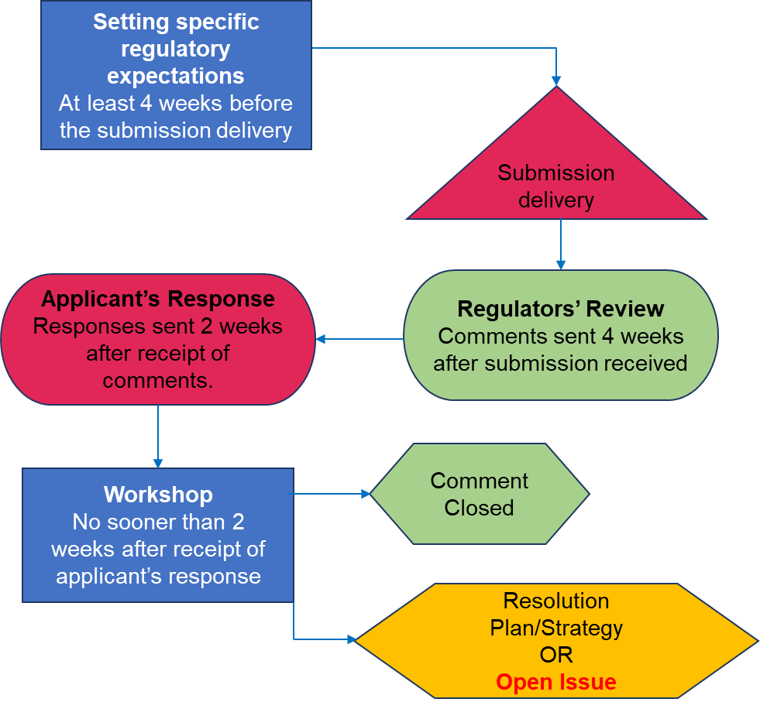

Figure 1: Submission review process

## 

## Specific regulatory expectations

For each submission, the regulators will present their expectations by reference to the relevant guidance including ONR’s Safety Assessment Principles (SAPs), Security Assessment Principles (SyAPs), Technical Assessment Guides (TAGs) and the Environment Agency’s Radioactive Substances Regulation (RSR) Objective and Principles, and RSR Generic Developed Principles. This is also an opportunity for clarification and agreement on the submission’s scope and contents.

## Submission review and recording

The regulators will have a four week period to review the submission and:

* form a view on the extent to which expectations have been met;
* identify potentially significant shortfalls (gaps against regulatory expectations); and
* record observations, comments and questions on potentially significant shortfalls - to be fed back to the applicant.

## Applicant’s responses and regulators’ feedback

The applicant should respond to the regulatory review and inspectors will provide further commentary and / or advice on their adequacy.

If there are outstanding matters following the review, a technical convergence workshop will be convened to enable direct engagement on outstanding matters.

## Technical convergence workshop

Around two weeks after the regulators have provided feedback, a workshop may be held to discuss any unresolved comments. The applicant has the option to develop and present plans for resolving outstanding issues prior to any future regulatory engagement such as GDA.

The applicant will be given the opportunity to contribute to the workshop agenda, which may include additional regulatory advice and guidance on the topic(s) in question, if required.

## Summary report

The regulators will produce contact records after each engagement which will be shared with the applicant. At the end of the PDR, the regulators will produce a joint summary report containing:

* an overview of the submissions and workshop discussions.
* significant gaps against regulatory expectations and areas where changes to the strategy or design will be required to meet expectations;
* an indication of the regulators’ confidence in the applicant’s plan to meet expectations should the design be taken forward into future regulatory processes – as outlined in Table 1; and
* the PDR “comments-responses-feedback” tables for the reviewed submissions -attached as Appendices.

Table 1: Statements of confidence in regulatory expectations being met

|  |  |
| --- | --- |
|  | Confidence indicators |
| **Increasing level of confidence** | * There is understanding and potential for clear alignment with key regulatory expectations (e.g., ONR SAPs, SyAPs, ONMACS, RSR Objectives and Principles, RSR Generic Developed Principles and RGP) as the design progresses further. * A number of gaps have been identified by the report and/or regulatory review but these are not expected to preclude the design’s future development from a regulatory perspective. * Technical challenges may have also been identified by the applicant; however, they have been clearly presented, showing awareness of their significance and reasonable plans to address them. |
| * Gaps have been identified or there is clear potential for divergence from UK regulatory requirements. * Whilst the gaps are significant and challenge the concept design, there are grounds to expect that they could be resolved in the future. This may require a significant amount of work and regulatory attention but is not considered insurmountable in the context of the proposed development timescales. * The applicant may have indicated technical challenges and provided plans to address them. However, the regulator’s opinion is that these do not reflect some significant gaps, or there is clear misinterpretation of UK regulatory expectations / scope of work required to resolve them. * Overall, the gaps are significant but not insurmountable. |
| * There is evidence of significant misalignment with regulatory expectations. * The submission shows little or no evidence of design criteria used and there is little and/or no acknowledgement of the technical challenges the design will face to progress from UK regulatory perspective. * There is very limited potential for the design to meet UK regulatory expectations in the future without major changes. |

# References

|  |  |
| --- | --- |
| [1] | ONR, “ONR-GDA-GD-009 - New nuclear power plants: Early engagement for regulatory pathways,” [Online]. Available: https://www.onr.org.uk/media/3i5av4rq/ants-onr-gda-gd-009-nnpps-early-eng.docx. |
| [2] | ONR, “ONR-GDA-GD-006 - Guidance to Requesting Parties on the Generic Design Assessment (GDA) process for safety and security assessments of new Nuclear Power Plants (NPP),” August 2024. [Online]. Available: https://onr.org.uk/media/iexmextu/onr-gda-gd-006.docx. |
| [3] | ONR and EA, “Joint regulatory advice provided to the NDA on the suitability of its proposed options for the reuse of plutonium (ONR record reference: 2015/798),” 2015. |

1. Phase B of the AMR RD&D Programme commenced in April 2023. Through AMR RD&D, DESNZ is providing funding to support the development and demonstration of High Temperature Gas Reactor (HTGR) technology in the UK. ONR and the Environment Agency are providing advice and guidance to two HTGR projects and a Coated Particle Fuel project as part of the regulatory engagement aspect of the programme.
2. For example, joint regulatory advice from ONR and the EA on the suitability of proposed options for the reuse of plutonium provided to the Nuclear Decommissioning Authority (NDA) [3] and advice provided to government and vendors through earlier AMR programmes.