|  |
| --- |
|  |
| ONR Assessment Report  Generic Design Assessment of the Rolls-Royce SMR – Step 2 Assessment of Civil Engineering |



ONR Assessment Report

**Project Name**: Generic Design Assessment of the Rolls-Royce SMR

**Report Title**: Step 2 Assessment of Civil Engineering

**Authored by**: [Redacted]

**Report Issue No**: 1

**Document ID**: ONRW-2126615823-3203

**Publication Date**: Jun-24

© Office for Nuclear Regulation, 2024

For published documents, the electronic copy on the ONR website remains the most current publicly available version and copying or printing renders this document uncontrolled. If you wish to reuse this information visit [www.onr.org.uk/copyright](http://www.onr.org.uk/copyright) for details.

# Executive Summary

This report presents the outcomes of my civil engineering assessment of the Rolls-Royce Small Modular Reactor (SMR) as part of Step 2 of the Office for Nuclear Regulation (ONR) Generic Design Assessment (GDA). This assessment is based upon the information presented in version 2 of Rolls-Royce SMR Limited’s Environmental, Safety, Security and Safeguards (E3S) case chapters and supporting documentation.

ONR’s GDA process calls for a step-wise assessment, which increase in detail as the project progresses. The focus of my assessment in this step was towards the fundamental adequacy of the Rolls-Royce SMR design and safety case, and the suitability of the methodologies, approaches, codes, standards and philosophies which form the building blocks for the design and generic safety and security cases.

I targeted my assessment, in accordance with my assessment plan, at the content of most relevance to civil engineering against the expectations of ONR’s Safety Assessment Principles (SAPs), Technical Assessment Guides (TAGs) and other guidance which ONR regards as relevant good practice.

I targeted the following aspects in my assessment of the Rolls-Royce SMR E3S case:

* civil engineering safety case
* civil engineering design principles and methodologies
* samples of the proposed concept design for civil engineering structures systems and components

The assessment focused on the reactor island civil engineering structures, systems and components, with limited sample for other areas.

Based upon my assessment, I have concluded the following:

* Further work is required to present a fully developed safety case which meets UK relevant good practice. Required development of the safety case is identified in regulatory observation, ‘RO-RRSMR-001’ but specific findings from my report include: the need to provide fully defined safety functional requirements for civil engineering structures; to provide evidence of a clear and traceable golden thread from claims through to substantiation; and to provide clear evidence that the design options chosen and their subsequent design reduces risks As Low As Reasonably Practicable.
* The design principles and methodologies adopted, whilst on the whole meet UK relevant good practice, require further development to demonstrate that they are sufficient to enable the design and substantiation the civil structures.
* The concept design features that were sampled include a number of aspects which are considered ‘typical’ compared with other reactor plant designs and some areas which are novel. Subject to further detailed assessment and design justification, the options are considered viable.
* A number of residual matters have been identified for consideration during Step 3. None of these has resulted in a regulatory observation, but represent areas which require clarity or development. I am satisfied that these can be addressed by Rolls-Royce SMR Limited in Step 3.

Overall, based on my civil engineering assessment to date, and subject to the provision and assessment of suitable and sufficient supporting evidence, I have not identified any fundamental safety shortfalls that could prevent ONR permissioning the construction of a power station based on the generic Rolls-Royce SMR design.

# List of Abbreviations

AASHTO American Association of State Highway and Transportation Officials

ACI American Concrete Institute

AISC American Institute of Steel Construction

ALARP As Low As Is Reasonably Practicable

ASCE American Society of Civil Engineers

BDB Beyond Design Basis

BS British Standard

BUGS Back-up Generation Structures

CAE Claim, Argument, Evidence

CDM Construction, Design and Management

CE Conformité Européenne

CSS Containment Support Structure

DAC Design Acceptance Confirmation

DiD Defence in Depth

DOORS Dynamic Object Oriented Requirements System

DR Definition Review

DRP Design Reference Point

E3S Environment, Safety, Security and Safeguards

EC&I Electrical, Control and Instrumentation

EIMT Examination, Inspection, Maintenance and Testing

EN Euronorm

ENEA Italian National Agency for New Technologies, Energy and Sustainable Economic Development

ESWS Essential Services Water System

FEA Finite Element Analysis

FF Fundamental Function

FOAK First of a Kind

FSF Fundamental Safety Function

GDA Generic Design Assessment

GSE Generic Site Envelope

IAEA International Atomic Energy Agency

LDRB Low Damping Rubber Bearings

MCR Main Control Room

MKoP Mechanical Kit of Parts

MWe Megawatt Electric

MWth Megawatt Thermal

NEI Nuclear Energy Institute

NIST National Institute for Standards and Technology

ONR Office for Nuclear Regulation

PCCS Passive Containment Cooling System

PGA Peak Ground Acceleration

PSA Probabilistic Safety Assessment

PWR Pressurised Water Reactor

RCP Reactor Coolant Pumps

RC Reinforced Concrete

RD Reference Design

RGP Relevant Good Practice

RIBA Royal Institute of British Architects

RO Regulatory Observation

RP Requesting Party

RPV Reactor Pressure Vessel

RQ Regulatory Query

SAP Safety Assessment Principle(s)

SFAIRP So Far As Is Reasonably Practicable

SFR Safety Functional Requirements

SG Steam Generators

SMR Small Modular Reactor

SPC Seismic Performance Class

SSC Structure, System and Component

SSI Soil-Structure Interaction

SSG IAEA’s Specific Safety Guide

SSR IAEA’s Specific Safety Requirements

SSSI Structure–Soil–Structure Interaction

TAG Technical Assessment Guide(s) (ONR)

TSC Technical Support Contractor

UK United Kingdom

UKCA United Kingdom Conformity Assessed

WENRA Western European Nuclear Regulators’ Association

Contents

Executive Summary 3

List of Abbreviations 5

1. Introduction 8

2. Assessment standards and interfaces 10

3. Requesting party’s submission 13

4. ONR assessment 19

5. Conclusions 51

References 53

Appendix 1 – Relevant SAPs considered during the assessment 60

Appendix 2 – Overview of the design 62

Appendix 3 – Seismic performance classification method flowchart 67

Appendix 4 – Civil engineering document map 68

# Introduction

1. This report presents the outcomes of my civil engineering assessment of the Rolls-Royce Small Modular Reactor (SMR) as part of Step 2 of the Office for Nuclear Regulation (ONR) Generic Design Assessment (GDA). This assessment is based upon the information presented in version 2 of Rolls-Royce SMR Limited’s Environmental, Safety, Security and Safeguards (E3S) case chapters (refs [1], [2], [3], [4], [5], [6], [7], and [8]) and supporting documentation.
2. Assessment was undertaken in accordance with the requirements of the Office for Nuclear Regulation (ONR) Management System and follows ONR’s guidance on the mechanics of assessment, NS-TAST-GD-096 (ref. [9]). The ONR Safety Assessment Principles (SAPs) (ref. [10]), together with supporting Technical Assessment Guides (TAGs) (ref. [11]), have been used as the basis for this assessment.
3. This is a Major report (refer to NS-TAST-GD-108 (ref. [12])).

## Background

1. The ONR’s GDA process (ref. [13]) calls for a step-wise assessment of the Requesting Party's (RP) submissions, with the assessments increasing in detail as the project progresses. Rolls-Royce SMR Limited is the RP for the GDA of the Rolls-Royce SMR design.
2. In April 2022 ONR, together with the Environment Agency and Natural Resources Wales (NRW), began Step 1 of the GDA for the generic Rolls-Royce SMR design. Step 1, which is the preparatory part of the design assessment process and mainly associated with initiation of the project and preparation for technical assessment in later steps, was successfully completed in 12 months.
3. Step 2 commenced in April 2023. This is the first substantive technical assessment step. The focus of ONR’s assessments in this step is towards the fundamental adequacy of the design and safety and security cases, and the suitability of the methodologies, approaches, codes, standards and philosophies which form the building blocks for the design and generic safety and security cases. The objective is to undertake an assessment of the design against regulatory expectations to identify any fundamental safety or security shortfalls that could prevent ONR permissioning the construction of a power station based on the design.
4. Prior to the start of Step 2 I prepared a detailed assessment plan for civil engineering (ref. [14]). This has formed the basis of this assessment and was also shared with the RP to maximise openness and transparency.
5. This report is one of a series of Assessments which support ONR’s overall judgements at the end of Step 2, which are recorded in the Step 2 Summary Report (ref. [15]).

## Scope

1. The assessment documented in this report is based upon the ‘Environment, Safety, Security and Safeguards’ (E3S) case for the Rolls-Royce SMR as summarised in the E3S case chapters and supporting documentation.
2. The overall scope of the Rolls-Royce SMR GDA is described in (ref. [16]). Rolls-Royce SMR Limited has indicated that it intends to complete a three step GDA, with the objective of receiving a design acceptance confirmation (DAC) from ONR and have aligned their GDA scope with this objective. The GDA scope defines the generic plant and layout and includes all systems, structures and components that are identified as being important to safety, security and safeguards, all modes of operation, and all stages of the plant lifecycle.
3. However, given the step-wise assessment during GDA, information has not been submitted for all aspects within the GDA Scope during Step 2. The following aspects of the E3S case are therefore out of scope of my civil engineering assessment:

* Detailed methodologies pertaining to the design of Class 3 and non-safety classified structures. I am satisfied that focusing on the class 1 and class 2 systems within step 2 is sufficient to identify whether any fundamental shortfalls exist in the general design and methodology.
* Assessment of the adequacy of the Dynamic Object-Oriented Requirements System (DOORs) tool. This is a key aspect of the RP’s management of requirements, claims and source data to underpin its analysis and design; however this will be assessed at the ONR project level and therefore I am satisfied that this aspect can be excluded from my assessment.
* Beyond design basis (BDB) assessment. No information on the methodology for assessing BDB events has been available at Step 2. The RP has a forward action plan to present this methodology at GDA Step 3.

1. My civil engineering assessment strategy is detailed in section 4.1 of this report. My assessment, via a sampling approach, focused on determining the adequacy of the civil engineering safety case, proposed design principles and methodologies and viability of the proposed design.

# Assessment standards and interfaces

1. For ONR, the primary goal of the GDA Step 2 assessment is to reach an independent and informed judgment on the adequacy of a preliminary safety, security and safeguards case for the reactor technology being assessed.
2. ONR has a range of internal guidance to enable Inspectors to undertake a proportionate and consistent assessment of such cases. This section identifies the standards which have been considered in this assessment.
3. This section also identifies the key interfaces with other technical topic areas.

## Standards

1. The ONR Safety Assessment Principles (SAPs) (ref. [10]) constitute the regulatory principles against which the RP’s case is judged. Consequently, the SAPs are the basis for ONR’s assessment and have therefore been used for the Step 2 assessment of the Rolls-Royce SMR.
2. The International Atomic Energy Agency (IAEA) safety standards (ref. [17]) and nuclear security series (ref. [18]) are a cornerstone of the global nuclear safety and security regime. They provide a framework of fundamental principles, requirements and guidance. They are applicable, as relevant, throughout the entire lifetime of facilities and activities.
3. Furthermore, ONR is a member of the Western European Nuclear Regulators Association (WENRA). WENRA has developed Reference Levels (ref. [19]), which represent good practices for existing nuclear power plants, and Safety Objectives for new reactors (ref. [20]).
4. The relevant SAPs, IAEA standards and WENRA reference levels are generally embodied and expanded on in the TAGs (ref. [11]). The TAGs provide the principal means for assessing the civil engineering aspects in practice, except where more recently published international guidance is available, and is considered to represent relevant good practice (RGP).

### Safety Assessment Principles (SAPs)

1. The key SAPs applied within my assessment are ECE.1 and ECE.2. Many other SAPs have been applied within my assessment, but these particular SAPs are most applicable to my civil engineering assessment. Details of specific SAPs are included within the assessment section of this report.
2. A list of the SAPs used in this assessment is recorded in Appendix 1.

### Technical Assessment Guides (TAGs)

1. The following TAGs have been used as part of this assessment:

* NS-TAST-GD-005 - Regulating duties to reduce risks to ALARP (ref. [21])
* NS-TAST-GD-017 - Civil Engineering (ref. [22])
* NS-TAST-GD-051 - The Purpose, Scope, And Content of Safety Cases (ref. [23])
* NS-TAST-GD-094 - Categorisation Of Safety Functions And Classification Of Structures (ref. [24])
* NS-TAST-GD-096 - Guidance on Mechanics of Assessment (ref. [9])

### National and international standards and guidance

1. The following international standards and guidance have been used as part of this assessment:

* IAEA, Site Evaluation for Nuclear Installations, Specific Safety Requirements No. SSR-1 (ref. [25])
* IAEA, Safety of Nuclear Power Plants: Design, Specific Safety Requirements No. SSR-2/1 (ref. [26])
* IAEA, Format and Content of the Safety Analysis Report for Nuclear Power Plants, Specific Safety Guide No. SSG-61 (ref. [27])
* IAEA, Seismic Hazards in Site Evaluation for Nuclear Installations, Specific Safety Guide No. SSG-9 (ref. [28])
* IAEA, Seismic Design for Nuclear Installations, Specific Safety Guide No. SSG-67 (ref. [29])
* IAEA, Design of Nuclear Installations Against External Events Excluding Earthquakes, Specific Safety Guide No. SSG-68 (ref. [30])
* IAEA, Safety Safety Aspects of Nuclear Power Plants in Human Induced Events, Safety Report Series No. 86 (ref. [31]), 87 (ref. [32]) and 88 (ref. [33])

## Integration with other assessment topics

1. To enable my assessment, I worked closely with other topics as part of my civil engineering assessment. Similarly, other assessors sought input from my assessment. These interactions are key to the success of GDA to prevent or mitigate any gaps, duplications or inconsistencies in ONR’s assessment.
2. The key interactions with other topic areas were:

* External hazards on development of the generic site envelope (GSE) (ref. [34]), seismic and aircraft crash hazards, the aseismic bearings and the hazard shield.
* Internal hazards on the layout development and the identification of civil engineering structures, systems and components (SSCs) that are claimed as barriers to internal hazards.
* Structural integrity on interfaces between the containment (structural integrity topic) and the containment support (civil engineering topic), boundaries of modular steel structure assessments, and the aseismic bearings.
* Mechanical engineering on EIMT requirements for mechanical equipment and layout constraints.
* Conventional health and safety on proposed construction and EIMT; and
* Life fire safety on life fire safety requirements and the civil engineering design.

## Use of technical support contractors

1. During Step 2, I engaged Technical Support Contractors (TSC) to support the following specific aspects of my assessment of civil engineering for the Rolls-Royce SMR:

* the adequacy of proposed design and analysis methodologies, including codes and standards adopted for the design of civil engineering SSCs. This was achieved by: document review, technical workshops and raising Regulatory Queries (RQs). The TSC summarised their assessment in two technical reports which are references to this report (refs. [35] and [36]).

1. The TSC provided me with technical advice and supported my assessment, working under my close direction and supervision. It should be noted that all regulatory judgements have been made exclusively by ONR.

# Requesting party’s submission

1. Rolls-Royce SMR Limited submitted a series of E3S chapters, or summary reports, and other supporting references, which outline the E3S case for the generic Rolls-Royce SMR design. This section presents a summary of the RP’s preliminary safety case for civil engineering. It also identifies the documents submitted by the RP which have formed the basis of my civil engineering assessment of the Rolls-Royce SMR.

## Summary of the Rolls-Royce SMR design

1. The generic Rolls-Royce SMR design is a three loop Pressurised Water Reactor (PWR) with a target electrical power output of 470 MWe (from a thermal power of 1,358 MWth) and a design life of 60 years for non-replaceable components.
2. The Rolls-Royce SMR design has been developed by the RP based upon well-established PWR technology, in use all over the world. Innovation comes in the form of its modular approach to construction which would see the majority of the power station built in factory conditions and assembled on site.
3. The reactor itself is of a typical PWR design, including a steel Reactor Pressure Vessel (RPV) holding fuel assemblies, Steam Generators (SG), Reactor Coolant Pumps (RCP) and piping, all held within a steel containment vessel. The reactor is equipped with a number of supporting systems for normal operations and a range of safety measures are present in the design to provide cooling, control criticality and contain radioactivity under fault conditions. Passive safety features are preferred to active components, reflecting the RP’s design philosophy.
4. An overview of the layout and civil engineering structures of the design is provided in ‘Appendix 2 – Overview of the Design’ of this report to provide context for the reader.

## E3S case approach and structure

1. Rolls-Royce SMR Limited has chosen to develop its cases in a holistic manner, as an Environment, Safety, Security and Safeguards (E3S) case. The overall objective for the E3S case is to demonstrate that the design will ‘protect people and the environment from harm’.
2. This means that, although the case made for each of the E3S purposes (i.e. environment, safety, security and safeguards) will inevitably be different at the top level, it will draw upon common evidence outputs (as well as other non-common outputs) to substantiate each of the purposes. This is claimed to offer benefits in terms of clarity, integration and understanding impacts from any changes to the case.
3. The E3S case is being developed using a three-tier hierarchy and incorporating a claim, argument and evidence (CAE) structure, with the highest-level claims being derived from the RP’s own E3S principles. The highest level of the three tiers is the RP’s Tier 1 E3S chapters, with the lower tiers providing more detailed arguments and evidence. This is illustrated in Figure 1.

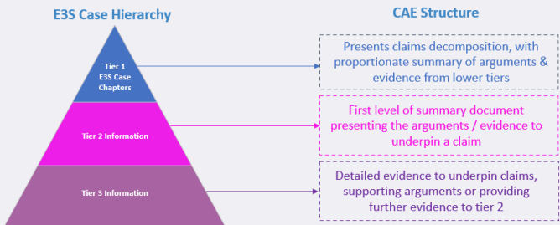

Figure 1 - Claim, Argument and Evidence (CAE) structure within the E3S hierarchy (ref. [1])

1. The structure of the E3S case largely aligns with the IAEA guidance for safety cases, SSG-61 (ref. [27]), supplemented to include UK specific expectations and expanded to include the other E3S purposes.

## Summary of the requesting party’s E3S case for civil engineering

1. The aspects covered by the Rolls-Royce SMR safety case for civil engineering can be broadly summarised as followed:

### The generic Rolls-Royce SMR civil engineering safety case

1. This section provides an overview of the generic Rolls-Royce SMR civil engineering safety case that has been submitted by the RP during GDA. Further details and references to the specific technical content within the RP’s documentation that pertain to my assessment are provided in Section 4 of this report.
2. The claims arguments and evidence are summarised in the ‘E3S Case Route Map’ (ref. [37]).
3. The claims arguments and evidence structure adopts the following approach:

* fundamental objective
  + fundamental claims
    - chapter top level claim
    - sub-claims (levels 1-4)
    - tier 2 arguments / evidence

1. The chapter level claim corresponding to ‘E3S Case Chapter 9B: Civil Engineering Works and Structures’ (ref. [4]) is:
2. “Civil structures are conservatively designed and verified to deliver E3S functions through-life, in accordance with the E3S design principles, to reduce risks to ALARP…”
3. The associated level 1 sub-claims can be summarised as:

* The requirements for the structures are identified
* The design of the structures will meet the requirements
* The structures are designed for the full lifecycle

1. The suite of documentation that will comprise the full E3S case (i.e., Tiers 1, 2 and 3) will be mapped out in a CAE Route Map to the applicable claims. The document map for civil engineering outlines the current vision for the safety case hierarchy under chapter 9B, as shown in ‘Appendix 4 – Civil Engineering Document Map’. GDA Step 2 submissions fall under ‘claim’ and ‘argument’ sections.

### Civil engineering structures within the GDA scope

1. The civil engineering scope for the GDA is defined in reference [16]. The civil structures included within the scope of GDA are:

“1. Reactor Island Structures including:

a. Hazard Shield

b. Raft Foundation and retaining walls

c. Seismic Isolation System (aseismic bearing and pedestals)

d. Containment Support Structure

e. Safeguards Block[1]

f. Fuelling Block

g. Ancillary Block

h. Auxiliary Block

i. Access Block

j. Containment Internal Structures

2. Essential Services Water System Structures (ESWS) including:

a. Foundations to the ESWS Cooling Tower

b. Foundations to the ESWS make-up water storage tanks

c. Service culverts housing ESWS pipework

3. Back-up Generation Structures including:

a. Structures supporting and housing the back-up generation system and associated fuel store

b. Service culverts housing back-up generation electrical cables

4. Structures which may impede the function of Class 1 and Class 2 SSCs if subject to failure”

### ALARP

1. Chapter 9B references ALARP in the chapter level claim (see paragraph 42). There is an additional sub-claim with specific reference to ALARP; however this is limited to consideration of design improvements which will be evidenced by substantiation reports in Step 3.
2. E3S chapter 24 ‘ALARP Summary’ has an associated high level claim that risks are reduced ALARP. It includes a sub-claim that SSC design reduces risk ALARP through-life for which chapter 9B is cited as evidence. Other notable features of these claims include conventional health and safety, safety analysis, understanding of novel features, and overall site layout, which are all cited to reduce risks to ALARP.

## Basis of assessment: requesting party’s documentation

1. The principal documents that have formed the basis of my civil engineering assessment of the E3S case are detailed in this section. In addition to these documents, some supporting reference were requested for review. Details of supporting references are provided in the relevant parts of Section 4 rather than in this section.
2. E3S Chapter 3 ‘E3S Objectives and Design Rules for Structures, Systems and Components’ (ref. [3]) provides the generic E3S design basis, covering E3S functions and functional requirements, numerical targets for analysis of the design, the concept of Defence in Depth (DiD) and its application, application of design requirements to classified SSCs, codes and standards selection commensurate with safety classification, safety analysis techniques, and the E3S categorisation and classification methods.
3. E3S Chapter 9B ‘Civil Engineering Works and Structures’ (ref. [4]) is the principal civil engineering chapter. It presents the overarching summary and is entry point to the design and safety information for the civil structures of the Rolls-Royce SMR. The following documents represent supporting references to Chapter 9B (as shown in Appendix 4 – Civil Engineering Document Map):

* Overview of Civil Engineering Structures (ref. [38]) provides an overview of the Rolls-Royce SMR design, plant layout and structural philosophy.
* Design basis documents summarise the safety claims applicable to each structure and present the safety functional requirements (SFRs) applicable to each facility. The design basis documents submitted for Step 2 are:
  + Design Basis for Reactor Island Structures (ref. [39])
  + Design Basis for Back-up Generation Structures (ref. [40])
  + Design Basis for Essential Services Water System (ESWS) Structures (ref. [41])
* The ‘Codes and Standards Policy’ (ref. [42]) presents the rationale for the codes and standards to be adopted by the civil and structural disciplines in the design through consideration of RGP and previous GDAs assessed by ONR.
* The ‘Material Code Compliance’ (ref. [43]) establishes the compatibility of adopting European/British material standards in combination with American design codes.
* The ‘Generic Design Parameters’ (ref. [44]) provides design data that applies to all safety class 1 and 2 civil engineering structures.
* The’ Structural Design Method Statement’ (ref. [45]) details the global and local analyses principles and methodologies to be adopted for Class 1 and 2 structures.
* The ‘Aircraft Impact Structural Philosophy and Methodology’ (ref. [46]) document provides an overview of plant philosophy for protection against aircraft impact, and an identification of systems to be protected through duplication / separation, or by provision of an aircraft impact protection structure.
* Design description documents (refs. [47] [48] [49] [50] [51] [52] and [53]) provide detailed information for a specific structure or group of structures.

# ONR assessment

## Assessment strategy

1. My assessment strategy was informed by the Step 2 objectives identified in ONR’s Generic Design Assessment Guidance to Requesting Parties (ref. [13]) as summarised in paragraph 6 of this report and ONR’s Guidance on Mechanics of Assessment (ref. [9]). As the RP’s methodologies were still under development, and the design was in a concept development phase, a focus of my civil engineering assessment in Step 2 was to de-risk areas of potential regulatory challenge by seeking to understand the RP’s vision of how the final safety case and methodologies will be presented. This was supplemented by a review of the RP’s concept design to establish alignment between the methodologies proposed and the context in which they will be applied. This included engagement between myself, my technical support contractor and various specialists from the RP in technical workshops and use of regulatory queries. This assessment does not capture all matters but presents my key findings in respect of the overall Step 2 objectives.
2. The focus of my assessment was identified in the Step 2 civil engineering assessment plan (ref. [14]), and summarised as:

* Generic safety case: I assessed the generic safety case due to its important role in identifying the relative safety significance of civil engineering structures and their requirements, which in turn informs their design, substantiation and overall demonstration that risks have been reduced to ALARP. I sampled topics to gain confidence that the safety case development is in accordance with relevant good practice. The aspect is covered in section 4.2.
* Design principles and methods: I assessed the RP’s proposed approach to the design to gain confidence that the adopted approach is in line with relevant good practice (RGP), with a focus on the approach for safety Class 1 and 2 SSCs. The aspect is covered in section 4.3.
* Sample of proposed design features: I sampled the proposed design of the safety significant structures, as informed by my understanding of the safety case. The purpose of this was to gain confidence that the design could be viable (with demonstration to follow in Step 3) and to identify whether there are any potential ‘showstoppers’ which could preclude the deployment of the design in the UK. The aspect is covered in section 4.4.

1. During my assessment timescales, the design was subject to significant layout changes. Furthermore, the design maturity reflected by the submissions was at DR1 (see section 4.2.2) meaning a number of concepts were still under consideration by the RP. Whilst the RP defined a single design option as part of DRP1, some aspects were less mature than others during Step 2. In response to these points, I have adapted my assessment and sampling strategy. In particular, some aspects of my sample of design solutions, as covered in section 4.4, are somewhat limited.
2. My Step 2 assessment represents my view of the assessment topics (as stated in paragraph 52) at a point in time. I have carried out my assessment based on whether the design is likely to meet UK RGP based on proposed methodologies and principles adopted. In some areas where insufficient detail has been available in Step 2, or where further justification is required, I have identified these as residual matters for Step 3. These are not necessarily significant shortfalls in themselves, but will nevertheless require consideration in Step 3 as part of the in-depth assessment of the safety case (as per ONR’s Guidance to Requesting Parties (ref. [13]). Some items will be subject to ‘normal business’ as part of the Step 3 assessment; such items are not specifically identified.

## Assessment of the generic civil engineering safety case

### Civil engineering GDA scope

1. During my assessment, I queried which structures would be included under the criteria ‘structures which may impede the function of Class 1 and Class 2 SSCs if subject to failure (Section 3.3.2). The RP responded with structures identifed which meet the criteria stated in item 4 (ref. [54]); however, several of these structures are not explicitly covered in the civil engineering submissions. An example structure is the architectural covering, proposed to cover the reactor and turbine island.
2. It is a residual matter that the RP should confirm the full list of the civil engineering SSCs considered within scope of GDA for Step 3. The RP is expected to identify any structures which may impede the function of Class 1 and Class 2 SSCs if subject to failure which are excluded from the GDA scope. All structures within scope of GDA are expected to be covered by the E3S case.

### Design maturity and the design reference point

1. This section presents the design maturity of the RP’s design and the RP’s selected design reference point (DRP) for Step 2 of the GDA.
2. Ref. [55] states that the level of design maturity for an SSC is described in terms of the Definition Review (DR) gates, i.e. progressive gated reviews held to assess and confirm the maturity of design definitions (refs. [16] and [55]). I have summarised key points of the definitions in the following paragraphs.
3. Definition Review 1 (DR1):

* a number of preferred concepts are under consideration
* E3S requirements are well understood but not fully defined

1. Definition Review 3 (DR3)

* a single concept has been selected
* E3S requirements are fully defined for the chosen concept

1. Definition Review 5 (DR5) (critical definition review)

* complete definition ready to be released to customer and the supply chain
* E3S case provides sufficient confidence that SSC can be released for manufacture

1. In response to RQ-01146 (ref. [54]), the RP stated that the design submitted in Step 2 is at DR1 and the design submitted in Step 3 will be at DR3 level of maturity. It was stated in RQ--01146 (ref. [54]) that, for the civil engineering design, DR1, DR3 and DR5 broadly align with Royal Institute of British Architects (RIBA) stages 2, 3 and 4 respectively. Noting that the design is at DR1 sets useful context for my assessment of subsequent sections, for example in relation to developing a fully developed E3S requirements and evidence for choosing one concept over another.
2. At the time of drafting this report the RP’s design reference point (DRP) for Step 2 GDA has been defined within its GDA Design Reference Report (DRP1) (ref. [56]). It states the baseline design for GDA Step 2 outlining the physical system descriptions and requirements that form the design at that point in time. I am satisfied that this reflects the design and is consistent with the response to RQ-01227 (ref. [54]).
3. I note that, whilst the DRP has been set in accordance with GDA requirements, the RP is still in the preliminary concept definition phase of their project (aligned to DR1) and in practice the RP is still considering a number of concept options. My assessment is limited to the options presented in the DRP (ref. [56]).

### Safety categorisation and classification for civil engineering SSCs

1. In this section I have assessed submissions against the RGP contained within IAEA SSR 2/1 (ref. [26]), requirement 22, ‘safety classification’, ONR SAP ECS.2 (ref. [10]) and IAEA SSG-67 (ref. [29]).
2. I note that the guidance contained within IAEA SSG-67, in respect of seismic performance classification, has been published more recently than ONR TAGs NS-TAST-GD-094 (ref. [24]) and NS-TAST-GD-017-1 (ref. [22]).
3. The safety categorisation and classification of civil structures is outlined in the design basis documents (refs. [39], [40] and [41]). I have summarised the classifications in Table 1 of Appendix 2 of this report. Whilst I note that most significant structures have been identified and classified, it is expected a definitive list of safety classified civil engineering SSCs is available for Step 3 which would aid clarity in respect of IAEA SSR 2/1 requirement 22 and SAP ECS.2, which requires identification of all items important to safety. This is somewhat related to my assessment relating to the scope (Section 4.2.1). I consider this should be fairly straightforward for the RP to address in Step 3 once the design has matured.
4. I sampled the design basis for reactor island structures (ref. [39]) which states that the assigned safety category is based on the highest safety categorisation assigned to an SSC which is housed within the respective structure. Also, the quantity of radioactive material is considered, which results in the Auxiliary Block - Sector 2 being assigned as safety class 2 even though it contains SSC with a maximum of safety class 3. I judge this to be a reasonable approach to classifying the overall structure, and in line with the guidance provided in ONR’s TAG NS-TAST-GD-094 (ref. [24]); however the lower seismic performance classification assigned would appear to undermine this approach (see paragraph 72).
5. I have sampled the seismic performance method (ref. [57]) which presents the method for assigning seismic performance classifications to SSCs. There are three seismic performance classifications (SPC) identified in ref. [57] which broadly correspond to the E3S classification:

* SPC1
* SPC2
* SPC3

1. All safety class 1 and 2 SSC will be assigned as SPC1. Safety class 3 SSC could be assigned any of the SPC categories, dependent on requirements. The seismic performance classification flowchart is provided in ‘Appendix 3 – Seismic Performance Classification Method Flowchart’.
2. The adopted seismic performance classification method (ref. [57]) broadly aligns with IAEA SSG-67 (ref. [29]). However, there are some differences, particularly in relation to the performance requirements of lower classified SSC. For example, there are no explicit requirements to ensure failure of an SPC3 SSC does not adversely interact with safety classified SSC - the rationale being that this requirement is captured by SPC2 (RQ-01130 ref. [54]). The categorisation and classification method (ref. [58]) does acknowledge consideration of credible failure paths, due to internal or external hazards, but could more explicitly identify requirements. This is a residual matter for consideration in Step 3.
3. I have identified inconsistencies in the application of the seismic performance classification. For example, the Auxiliary Block Sector 2 is a Safety Class 2 SSC but is only assigned as a SPC2 SSC. This appears to be in contradiction to the seismic performance methodology (ref. [57]) that indicates a minimum classification of SPC1. Therefore, I consider that the RP is expected to review this area to ensure their seismic performance classification method is correctly applied.
4. From a civil engineering perspective, I am satisfied that the safety classification and seismic performance classification of civil structures generally aligns with UK RGP. However, as noted above, I have identified some departures from RGP and the RP’s own methodologies in respect to seismic performance classifications of structures, which are residual matters for Step 3.

### Safety functional requirements of civil engineering SSCs

1. In this section I have assessed sampled submissions against the RGP contained within IAEA SSR 2/1, requirement 4, ‘fundamental safety functions and requirement 14, ‘design basis for items important to safety’ (ref. [26]), SAP ECE.1 (ref. [10]) and TAG NS-TAST-GD-017-1 (ref. [22]).
2. The Rolls-Royce SMR is being designed to achieve the three Fundamental Safety Functions (FSFs), at all lifecycle stages. These are defined in [3]:

* control of reactivity (CoR)
* control of fuel temperature (CoFT)
* confinement of radioactive material (CoRM)

1. The safety functional requirements of civil structures are outlined in the design basis documents (ref. [39], [40] and [41]).
2. I have sampled the design basis for reactor island structures (ref. [39]) which provides the safety functional requirements applicable to reactor island structures in tabular form. Several civil structure safety functions are identified and broadly categorised:

* protect
* support
* confine
* shield
* withstand

1. The link between fundamental safety functions and civil structure safety functions is provided in Table 3 of ref. [39]. From my assessment I consider this to be in accordance with RGP identified in IAEA SSR 2/1 Requirement 4 ‘fundamental safety functions’. The RP acknowledges that this is not the entirety of functions (ref. [39] and RQ-1048 ref. [54]). There are also functions to shield and provide physical space to house SSCs.
2. The requirements schedule (Table 6 of ref. [39]) identifies the hazards, safety category and classification, functional requirement and acceptance criteria and substantiation method.
3. The RP acknowledges (ref. [39]) that the civil structure safety functional requirements are placeholders pending development of the Fault Schedule and subsequent input into DOORS. Additionally, requirements for combined loading and beyond design basis are identified as future work in the ‘forward action plan’ (Table 5 of ref. [39]) and I note these are considerations of SAP ECE.1. The RP noted that the intent is not to incorporate individual barriers into the design basis documents, but to incorporate them into the applicable ‘Design Description’ documents during Step 3 (RQ-01125 - ref. [54]) as the layout is refined. Related to this, I have observed that, whilst the design basis covers overall ‘areas’, there is a shortfall against IAEA SSR 2/1 Requirement 14 which requires that the design basis for each item important to safety shall be systematically justified and documented.
4. Whilst I have identified these areas for improvement, I do not consider the position unreasonable for this stage of the assessment but there are shortfalls against UK RGP which will need to be addressed in Step 3. For example, I consider that lack of clarity regarding structural fire resistance requirements to be a more significant shortfall (as discussed in Section 4.4.3) and these are residual matters for consideration in Step 3, (also see section 4.2.5).

### Structure of the safety case and demonstration of the golden thread

1. For this section of my assessment I have considered the RGP outlined in ONR TAG NS-TAST-GD-017 (Annex 1, ref. [22]) which defines the golden thread:
2. “The golden thread is a clear line of information from the original hazard derivation through to the claim made on the civil engineering structure, which continues on to the presentation of how the structure will meet the claims made upon it.”
3. Guidance on safety cases can be found in ONR TAG NS-TAST-GD-051 (ref. [23]), in this section, the following points are of relevance:
   1. “should present a clear and coherent trail from safety claims (assertions), through the arguments (reasoning) to the evidence that supports the conclusions. Claims and arguments across the safety case should be consistent.”
   2. “A safety case should be structured in a logical manner and be demonstrably complete.”
   3. “The top tier document should describe the facility and its operation, summarise the main hazards and the safety functions required to control them, explain the means of delivering these functions, and summarise the main conclusions, including whether risks are reduced ALARP. It should be meaningful if read in isolation, as well as providing the main entry point and clear links (‘sign-posting’) to the safety case documentation as a whole. For large or complex safety cases, the top tier summary document is sometimes known as the Safety Report.”
4. I have also considered SAPs ECE.1, ECE.2 and IAEA SSR 2/1 Requirement 16.
5. The RP has produced the ‘Claims, Arguments and Evidence Routemap’ (ref. [37] and a visual document map specific to chapter 9B (Appendix 4 – Civil Engineering Document Map). This is a useful aid in understanding the vision of the safety case in sign-posting.
6. Based on sampled submissions during Step 2, I have found the golden thread difficult to follow. I believe this is partly due to the desire to use the DOORS system as a tool for requirements management which is expected to be able to present a clear and traceable golden thread from requirements to substantiation. However the maturity of this and also of the safety analysis and internal hazards and fault schedules results in an approach that is not entirely joined up and is a ‘work in progress’. There is also inconsistent use of terminology in the various documents which adds to further confusion. I have referenced the current maturity of the safety functional requirements in paragraph 80, and my judgement is also applicable in respect of the golden thread.
7. The RP recognises that the requirements management process using DOORs requires development; however I consider that, if this is not addressed early in Step 3, it could present challenges in designing and subsequently demonstrating that civil engineering SSCs adequately fulfil their safety functional requirements.
8. The principal E3S chapter I have assessed is E3S Chapter 9B (ref. [4]) which is the entry point to the civil engineering safety case. Whilst I have primarily assessed the underlying evidence, I note that Chapter 9B (which was submitted after issue of the supporting references) is consistent with the detail contained within these supporting references.
9. Based on my assessment, I note that further work is required to develop the golden thread. I consider this to be a shortfall against UK RGP and note that this is captured by the project wide regulatory observation, RO-RRSMR-001 (ref. [59]). However, I consider the matter should be resolvable and is a residual matter for consideration in Step 3.

### ALARP

1. I note that the overall claim for E3S Chapter 9B specifically claims that civil structures are designed to reduce risks ALARP (ref. [4]); also see paragraph 42 of this report. The RP cites a number of sub-claims to support this but there is a specific sub-claim for ALARP so I am unclear of the intending route to substantiate the ALARP aspect of the design.
2. The RP’s specific ALARP sub-claim is: “The design of the structures adopts ALARP, BAT and secure and safeguards by design principles”. This is the most directly relevant sub-claim in respect of ALARP. The discussion for ALARP is presented in the conclusion rather than throughout the body of the E3S Chapter 9B and is limited to three paragraphs and a set of bullet points. Some examples of how RGP and operational experience (OPEX) have informed the design sound reasonable (e.g. height of supporting pedestals for EIMT, extent of the seismic isolation system etc.) but no detail is provided to explain exactly what influence RGP and OPEX had. It is stated that ‘a systematic optioneering process with down-selection of design options based on relevant criteria that ensure risks are reduced to ALARP apply’. I queried further information on this in RQ-01126 (ref. [54]) and received information about the down selection and optioneering criteria. However no evidence of when this criteria has been applied for down-selecting civil structures was supplied in Step 2.
3. I note that the current design maturity (i.e. multiple concepts still under consideration) means that key decisions on structural concepts are yet to be made. Once these decisions are made, I expect there to be clearer justification for the selection of options, with evidence that the options chosen represent the ALARP solution to be available in Step 3. This would be better supported by commentary of ALARP and the ‘claims, arguments and evidence’ structure in the overarching E3S Chapter 9B in greater detail than is currently provided.

## Assessment of design principles and methodologies

### Selection of codes and standards

1. In this section I have sampled submissions against the RGP contained within IAEA SSR 2/1 requirement 9 ‘proven engineering practices’ and SAPs ERL.1 and ECS.3.
2. The RP’s approach to codes and standards is described in E3S Chapter 3 (ref. [3]). This is supplemented by a civil engineering specific policy (refs. [42] and [43]) and the structural design method statement (ref. [45]). Key points are:

* Strength design of nuclear safety related SSC (i.e. safety class 1, 2 and 3 SSC) adopts American standards (as confirmed in RQ-1107 and RQ-01145 - ref [54]).
* Strength design of non-nuclear safety related structures adopts European standards (including their relevant UK National Annex).
* Serviceability design considers a combination of American and European standards.
* Material specification is in accordance with European and British codes and standards.

1. In some cases, the RP’s approach does not adopt the most up-to-date version of the code, or includes codes that are known to be subject to withdrawal between now and plant commissioning (e.g. EN1992-1-1, Eurocode 2). TAG NS-TAST-GD-017-1 (ref. [22]) states the expectation that the most up-to-date version of a design code is to be adopted, unless use of the older revision can be demonstrated to be RGP. ONR GDA guidance to RP’s (ref. [13], paragraph 141) states that updates to codes and standards need to be considered. The RP has committed to undertaking a gap analysis of code revisions and confirmed in RQ-01121 (ref. [54]) that updates to codes and standards will be considered on a case-by-case basis. I am satisfied with this commitment and assessment of related updates will be considered in Step 3.
2. Furthermore, the RP is expected to provide further clarity and demonstrate compatibility of American standards with European and British material codes and standards. Examples include:

* CE/UKCA marking of structural steel to UK standards and alignment with American codes, the RP has committed to developing a report in response RQ-01163 (ref. [54]).
* Demonstration that the use of non-nuclear specific standards for the design of the aseismic bearings is suitably supplemented to achieve the required reliability (refer to paragraph 102 for further details).
* Geotechnical / foundation design aspects in relation to the use of BS EN 1997-1 and ACI 318-008.

1. The generic design parameters, including material properties, durability requirements, ground and soils properties for safety class 1 and 2 structures are defined (ref. [44]). I have not found any significant shortfalls against RGP in this area. There are some required clarifications which can be obtained during Step 3 as a residual matter. Note, my assessment of geotechnical aspects is covered in this report under section 4.3.5.
2. I note that the RP’s application of nuclear specific codes and standards to Class 3 structures is conservative and beyond TAG NS-TAST-GD-017-1 and the RP’s overarching codes and standards policy (ref. [3]).

#### Seismic analysis

1. The RP has confirmed in the structural design method statement (ref. [45]) that the seismic analysis method will be in accordance with ASCE 4-16 and ASCE 43-19. I am content that these codes represent RGP.
2. ASCE 43-19 requires the design response spectra to be based on the target performance goal and provides an approach to calculate this. SAPs (EHA.4 and FA.5) set a threshold for design basis events from external hazards at 1 in 10 000 years. The RP’s proposed approach is to base the design input spectra on the annual frequency of exceedance of 10-4  in line with SAPs (ref. [34]) which the ONR external hazard inspector has assessed (ref. [60]). The RP confirmed in RQ-01228 (ref. [54]) that they will corroborate the target performance goal for the isolation system to ensure compliance with ASCE 43-19. I am satisfied that this can be considered during the Step 3.

#### Elastomeric bearings

1. The RP has proposed a combination of US and European standards for the design of the elastomeric bearings (ref. [45]), which are part of the seismic isolation system. Analysis and general performance requirements will be in accordance with American codes (ASCE 4-16 and ASCE 43-10) and local verification and testing protocols will be in accordance with European codes (BS EN 1337-1, BS EN 15129) and ENEA guidelines (NNFISS-LP2-038). I consider that the codes proposed represent RGP in their respective areas and that combination of codes for the UK context would be difficult to avoid, but the compatibility of these standards as expected by SAP ECS.3 is yet to be demonstrated, (ref. [10], paragraph 173). The RP has stated in their response to RQ-01228 (ref. [54]) that this will be provided in Step 3. I note that these proposals include a comparison between American Association of State Highway and Transportation Officials (AASHTO) codes and European codes, but I am unclear what the rationale is for this these codes are not nuclear specific.
2. The European standards proposed (BS EN 1337-1 and BS EN 15129) are non-nuclear specific and limited information has been provided on how they will be supplemented to demonstrate adequate levels of reliability. The RP is expected to demonstrate that the non-nuclear specific codes adopted for the design of the elastomeric bearings will achieve the required level of reliability for a class 1 SSC in Step 3.

#### Summary of codes and standards assessment

1. In general, I consider the overall adoption of codes and standards to be aligned with RGP. However I have identified some shortfalls in specific areas which require further justification and potential improvements to demonstrate RGP is followed in these areas. These are a residual matters for consideration in Step 3.

### Modelling and analysis

1. In this section I have sampled submissions against the RGP contained within ONR TAG NS-TAST-GD-017-1 (ref. [22]) and SAPs as identified below:

* assumptions and simplifications used in the development of the model (ECE.12)
* conservatisms expected from the model (ECE.13)
* sensitivity studies (ECE.14)
* suitable methods to verify and validate the model and demonstrate that it accurately represents the behaviour of the structure (ECE.15)
* a description of the proposed modelling methodology; including how they are applied to design (EKP.3, EKP.4, EKP.5)
* analysis of consequential effects of internal and external hazards (EHA.6)

1. The modelling of CE structures is expected to adequately represent the characteristics of the materials and structural forms, such that the behaviours are adequately simulated in the analyses. Modelling invariably introduces departures from real world conditions. In these instances, the modelling assumptions are expected to be described and justified.
2. The proposed structural analysis methodology uses finite element analysis (FEA) for the determination of design effects. The FEA software packages that are utilised are summarised as follows:

* Abaqus - static, modal, response spectrum and time history analysis of reinforced concrete and steel structures (global models)
* Robot – Analysis and code checking of steel structures, including steel process clusters (local models)
* Plaxis 3D – geotechnical analyses
* post-processing of analysis results will be supplemented with Tekla Tedds and Mathcad. Additional in-house developed Python scripts are proposed to interface with Abaqus for a range of administrative tasks
* IDEA Statica is proposed for design of steelwork connections

1. I note that the software proposed is well established and am satisfied with their intended application.

#### Global and local models

1. The proposed analysis approach involves use of structural models at two scales for the design of civil engineering structures:

* Global Model - primarily for the design of the raft, pedestals, seismic bearings, basemat and reactor island concrete structures (with the steel process clusters modelled with representative mass and stiffness)
* Local Models - of concrete elements not modelled in the global model (e.g. walls equal to or less than 250 mm thick) and the steel process clusters

1. The Plaxis 3D geotechnical models feed into a number of different Abaqus global models, which are used either directly for the design of structural elements, or to generate secondary response spectra to feed into local models in Abaqus or Robot for design of other structures.
2. The RP has provided a high level overview of model interfaces, but further explanation of the interfaces, hierarchy and connectivity between different models is required. This is a residual matter for consideration in Step 3.
3. I am satisfied that the RP has demonstrated an approach to global and local modelling sufficient for Step 2.

#### Geotechnical analysis

1. The structural analysis of rafts for static load conditions is covered in the structural design method statement (ref. [45]). The method proposed by the RP uses linear elastic vertical springs that will be derived using Bentley Plaxis 3D (Plaxis 3D) geotechnical analyses. I note that the analysis methodology for structure-soil-structure interaction (SSSI) is excluded from the structural design method statement (ref. [45]). A forward action plan is identified by the RP (ref. [45]) which notes that the structure-soil interaction (SSI) effects are ‘considered appropriate for concept design development’ and indicates that SSI methodologies will be updated ‘as the design progresses’ and that SSSI methodologies will be developed and an update to the structural design method statement (ref. [45]) will be available for assessment early in Step 3. It is confirmed in the response to RQ-01146 (ref. [54]) that the structural design method statement (ref. [45]) will be updated to incorporate closure of forward action plans.
2. Plaxis 3D will be used for the geotechnical analysis to model raft foundations and develop springs for use in structural Abaqus models for static loading conditions. However details of the approach to development, use, and validation of the Plaxis 3D models for geotechnical analyses is missing from the structural design method statement (ref. [45]).
3. Whilst there is sufficient information at this stage of the design, I expect further clarification and substantiation for the geotechnical analysis to be provided in Step 3. Consideration of the suitability of the methodologies for the purposes of GDA is considered a residual matter for Step 3 assessment.

#### Seismic analysis

1. In assessing the RP’s seismic analysis approach, the following areas have been sampled:

* geotechnical analysis
* pounding
* response spectrum analysis
* mode selection

1. I note that limited information has been provided by the RP on the time history analysis used to derive secondary response spectra for local models in Step 2. This is a residual matter for consideration in Step 3.

#### Geotechnical analysis

1. The structural design method statement (ref. [45]) notes that springs and dampers for the dynamic model, used for the seismic load condition, are to be derived using National Institute of Standards and Technology (NIST) GCR 12-917-21 guidance, ‘Soil-structure interaction for building structures’ that is based on published solutions for a rigid raft. The RP noted that the rationale for use of NIST GCR 12-917-21 is because it is more comprehensive than guidance within ASCE 4-16 and allows for alternative methods of spring determination, which is acceptable under ASCE 4-16. My TSC has advised (ref. [36]) that there are omissions in the methodology, for example, the method of estimating degraded shear modulus to obtain foundation stiffness (ref. [35]). I consider this to be a residual matter for further consideration during Step 3.

#### Pounding

1. The RP confirmed in their response to RQ-01135 (ref. [54]) that the pounding risk is assessed and that a simplified representation (e.g. of the process clusters) in the global model allows assessment of the displacements sufficient to determine the risk of pounding. They also made it clear that local pounding risks within the local models will also be assessed. I consider this to be a reasonable initial approach in line with the intent of SAPs ECE.12 and EHA.6. The consideration of results and whether more rigorous methods are necessary will form part of Step 3.

#### Response spectrum analysis

1. The RP proposes (ref. [45]) response spectrum analysis for the seismic design of structural elements. This method is a frequency domain linear analysis method and is permitted under ASCE 4-16, only where bearings can be modelled accurately as linear viscoelastic elements for the chosen shaking intensity. Guidance on shear strain limits to meet this criteria is provided by NUREG/CR-7253 (ref. [61]), which states that low damping rubber bearings (LDRBs) can typically be modelled as linear elastic elements up to a strain limit of 200%. The RP’s current proposal is to consider strain limits between 100% and 250%. Testing is proposed by the RP to verify and validate the models (in ref. [50]) to verify and validate the numerical models. If the physical testing carried out does indeed validate the numerical models, then I consider the proposal to consider linear elastic behaviour between 100% and 250% should be able to be justified.

#### Mode selection

1. The proposed method (ref. [45]) includes calculating a significance factor to identify insignificant modes to be excluded from the response spectrum analysis. This method appears to be dependent on the mode shape scaling in the analysis software such that the decision about which modes to consider would be different for different software. The method differs from the widely adopted and well-established method of modal selection/truncation based on effective mass (which correlates with base shear and is invariant to mode shape scaling). The rationale for using the significance factor approach was provided is response to RQ-01162 (ref. [54]); however I have identified that the sensitivity of the method to mode shape scaling is a residual matter for Step 3.

#### Modelling

1. The modelling strategy is outlined in the structural design method statement (ref. [45]). Specific aspects of modelling that were sampled as part of my Step 2 assessment are:

* loading and section modifiers
* finite element mesh
* equipment modelling
* fluid in pools
* concrete walls

1. I have not included all of the technical details in this report; a comprehensive overview is provided in the assessment carried out by my TSC (Section 5.7 of ref. [35]). In summary, the modelling approach described in the structural design method statement (ref. [45]) is at a lower maturity than expected. This resulted in RQs being raised to gain further understanding of the RP’s intending modelling approach. The structural design method statement (ref. [45]) requires further development to expand and clarify the intended modelling approaches in some areas including, but not limited to; mesh sizing, proposed methods of element connections, mesh sensitivity proposals, detailed consideration of fluids in pools and tanks and modelling of concrete walls 250 mm and less. I consider this represents a shortfall in expected level of detail provided by the RP’s methodology for this stage of GDA, but not necessarily a shortfall in the approach adopted. This is a residual matter for consideration in Step 3.

#### Verification and validation

1. The RP has developed a verification and validation strategy in the structural design method statement (ref. [45]) with key points summarised below:

* Key parameters governing the structural response, as well as primary outputs from the finite element models, will be validated against hand calculations.
* The target criteria for the validation of finite element models is presented. There are a number of criteria but includes for example, total mass, maximum displacements and total base shear forces.
* A validation and verification flow chart for global and local models for Abaqus (a similar approach will be used for Robot). Example steps include detailed checks of the load case definition, detailed checking of analysis scripts, checking for conformity with SDMS and code compliance.
* Hand calculation checks to confirm magnitude of settlement values against Plaxis 3D outputs.

1. My TSC provided specialist technical advice on this matter (Section 5.12 of ref. [36]). No significant concerns or departures against UK RGP were identified by my TSC (ref. [36]); however several areas where insufficient detail or clarity provided in the proposed validation and verification methodology were identified. These include: insufficient detail on proposed verification of in-house custom use of python scripts, Tekla Tedds, Mathcad and IDEA Statica; documentation of target criteria for 1D (beam and column) elements and clarity regarding mesh sensitivity studies.
2. I consider the findings identified by my TSC to be residual matters for Step 3, and that the general approach is in line with SAPs ECE.14 and ECE 15. However, I note that timely development of detail in these areas is expected in the early stages of Step 3 to minimise regulatory challenge after the analyses is complete.

#### Summary of modelling and analysis

1. In general, I am satisfied that the approaches are broadly in alignment with UK RGP, as identified in paragraph 105; however there are areas of the analysis and modelling methodology that require further development and justification. This is a residual matter for consideration in Step 3.

### Concrete design

1. The structural design method statement (ref. [45]) includes insights, to varying levels of detail, into how the RP will design reinforced concrete components. In addition to more prescriptive calculations that are exhaustively defined by codes and standards, these insights cover, with reasonable clarity: reinforcement detailing, punching shear, torsion, fire resistance, crack control, and crack widths. There are, however, aspects that are not very mature, leading to queries relating to the following topics:

* precast concrete
* concrete shrinkage and creep
* strut-and-tie
* foundation pedestal design

1. Whilst aspects of these topics are residual matters for consideration in Step 3, I am satisfied that the general approach to concrete design is aligned with UK RGP and satisfactory for the current stage of design.

### Steel design

1. The steel design is predominantly associated with modular steel process clusters (these are discussed in section 4.4.3); design of steel trusses forming the hazard shield roof (see section 4.4.1) is under development. Key findings from my assessment are:

* IDEA Statica is proposed for standard connections and the use of Abaqus or testing will be used for novel connections. Full detail around modelling approaches and acceptance criteria are not provided in ref. [45];
* There is no indication whether novel connections will be designed to American, European or UK standards;
* The lateral force resisting system is still to be confirmed, and the SDMS (ref. [45]) will require update to reflect the chosen solution; and
* The methodology to assess dynamic loading (e.g. fatigue) will be included in future revisions of the SDMS (ref. [45]).

1. Whilst aspects of these topics are considered residual matters for Step 3, I am satisfied that the general approach to steel design is aligned with UK RGP and satisfactory for the current stage of design. The lack of clarity around structural resistance under fire loading will be considered in Step 3 (as noted in paragraph 24 and Section 4.4.3).

### Geotechnical considerations

1. The following documents provide requirements and guidance on site evaluation, including with respect to geological and seismic considerations:

* IAEA SSR-1 (ref. [25]) Site Evaluation for Nuclear Installations
* IAEA SSG-35 (ref. [62] Site Surveys and Site Selection for Nuclear Installations
* IAEA SSG-9 (ref. [28]) Seismic Hazards in Site Evaluation for Nuclear Installations
* ONR TAG NS-TAST-GD-013 (ref. [63]) on external hazards and
* ONR TAG NS-TAST-GD-017 (ref. [22]) on civil engineering.

1. Detailed site specific considerations are not expected for GDA, however the definition of the generic site envelope (GSE) is determined by the RP. ONR expectations in ONR-GDA-GD-007 (ref. [64]) state that the GSE “should be unambiguous and specify any site-related characteristics which have been explicitly included within or excluded from that definition”. It follows that any assumptions and parameters used for generic design of civil engineering SSC are expected to be consistent with the specified GSE. It may be acceptable to later propose installation of the plant on a site not within the bounds of the GSE, but significant re-design and assessment may be required.
2. Key references for this section are:

* Generic Design Parameters for Civil engineering (ref. [44])
* Geotechnical Design Parameters (ref. [65])
* Generic Site Envelope (GSE) (ref. [34])

1. The external hazards assessment covers broader assessment of the GSE (ref. [60]).
2. Six ground models with different strength and stiffness ranges are considered within the generic design parameters for civil engineering (ref. [44]):

* Stiff CLAY
* Dense SAND
* Weak ROCK
* Strong ROCK
* Stiff CLAY over strong ROCK
* Dense SAND over strong ROCK

1. The corresponding seismic spectra class is provided in the geotechnical design parameters report (ref. [65]), which references EUR soft, medium and hard spectra with an acknowledgement that “an additional class for very hard rock may be required, based on results from Wylfa.”
2. The GSE (ref. [34]) states that the Rolls-Royce SMR could be sited “at any of the sites identified in the document ‘National Policy Statement for Nuclear Power Generation (EN-6) Volume I and Volume II” and it is stated that specific sites ‘may’ result in behaviour outside selected ground models. Advice from my TSC (ref. [35]) is that ground models do not suitably bound all UK EN-6 sites[2] and may not be suitably extensive or robust to ensure that significant changes in design, or construction details can be avoided when considering UK site-specific deployment. Please refer to the external hazards assessment report (ref. [60]) for further details.
3. Further clarity is required regarding the use of the ground models for very hard sites in Step 3. I have raised queries in relation to the geotechnical parameters in RQ-01187 (ref. [54]) and RQ-01307 (ref. [54]). The External Hazards Inspector has raised this in their assessment report (ref. [60]) for this to be addressed in a future revision of the GSE. This is a residual matter for Step 3.

### Full lifecycle considerations

1. High level details have been provided in respect of constructability, EIMT and decommissioning. I have considered SAPs ECE.20, ECE25 and ECE.26. Constructability is particularly considered as part of the ‘build certainty’ proposal which includes minimising build schedule and maximising modular construction (RQ-01126 - ref. [54]).
2. I have identified potential concerns regarding EIMT of large equipment which may result in significant works to civil engineering structures through life if there are no such provision ‘designed in’ (see paragraph 165). However, some early evidence of a design provision for EIMT is discussed in paragraph 173.
3. The current level of detail is as expected for this stage of the design and I will seek further information in Step 3.

### Conventional Health and Safety

1. The Construction (Design and Management) Regulations 2015 (CDM) place duties on designers to eliminate, reduce, or control foreseeable risks that may arise during construction, maintenance, and use of a building, so far as is reasonably practicable during the design process. Risk management is a requirement, and a risk register is expected, to systematically organise, communicate downstream, and record the risk management process. The risk register is expected to be continuous throughout the design and construction.
2. I raised RQ-01119 (ref. [54]) to ascertain how health and safety is being managed during the design phase. The response (ref. [54]) referenced generic processes and the suggested consideration of health and safety aspects to be future work, rather than being explicitly considered during the design development as expected. Aside from referencing generic templates, no further evidence was presented by the RP.
3. Notwithstanding the above, the RP has provided indications that constructability has been considered and developed with early contractor engagement (e.g. in ref. [49]). It is claimed in the design description for the reactor island (ref. [49]) that the principles used have ‘benefits to health and safety during construction’, but specific details of these benefits are not provided.
4. I would expect to see more evidence of health and safety considerations at this stage and I will seek further information in Step 3.

### Aircraft Impact Assessment

1. For my assessment of the overarching methodology, I have considered my assessment against the expectations outlined by ONR (ref. [66]) and RGP outlined in SAP EHA.8:

* The direct and indirect effects of aircraft crashes on structures, systems and components needed to achieve a stable, safe state should be analysed. These should include effects relating to mechanical resistance, vibrations and structural and component integrity.
* The analysis should include fire and explosion hazards deriving from aircraft crashes including fires caused by aircraft fuel, fire ball and pool fire combinations and other consequential fires due to the aircraft crash. Buildings (or parts of buildings) containing nuclear fuel or housing structures, systems and components needed to achieve a stable, safe state should be designed to prevent aircraft fuel from entering them.
* ONR’s regulatory expectations for the malicious aircraft safety case demonstration are outlined in (ref. [66]) which states that malicious aircraft impact is to be considered as a beyond design basis event. This provides details on the expectations for the threat definition and the limit for the dose experienced by a person off-site amongst other expectations.

1. I have also considered specific guidance international guidance within Nuclear Energy Institute (NEI) standard 07-13_8P (ref. [67]) and IAEA Safety Report Series 86, 87 and 88 (refs. [31], [32] and [33]). I have been provided with specialist technical advice on this topic via my TSC (ref. [36]).
2. The RP considers both accidental and malicious aircraft impact to be beyond design basis conditions (ref. [46]). I note that the external hazards assessment has concluded that accidental aircraft impact is beyond design basis (ref. [60]).
3. ONR has recently revised the malicious aircraft impact expectations (ref. [66]) following recent research. ONR and the RP engaged during the final stages of this research to enable the RP’s design to progress based on up-to-date ONR expectations for the threat definitions (ref. [68]). The RP’s proposed threat definition is outlined by the RP (ref. [69]). I have reviewed the threat definition and received technical advice from specialist TSC (ref. [36]) and judge that is in line with the expectations (ref. [66]) and as discussed in with the RP (ref. [68]).
4. The RP’s aircraft impact philosophy and methodology (ref. [46]) states that control of the three fundamental safety functions (FSFs) will be maintained following an aircraft impact (refer to paragraph 75). The RP has shown that they are trying to choose acceptance criteria which would be acceptable under both sets of guidance, with a forward action plan to confirm the adopted performance level of the aircraft impact protection structures.
5. In the RP’s submission (ref. [46]) it is stated that the majority of the systems ensuring control of the FSFs following aircraft impact are located within the Hazard Shield, with some exceptions. In RQ-01171 (ref. [54]) and RQ-01172 (ref. [54]), the RP confirmed, “all the required SSCs, including support services required up to 72 hours, are provided within the Hazard Shield”. The RP noted that further clarity on safety measures required to support the FSFs following aircraft impact will be available in Step 3.
6. The RP states (ref. [46]) that detailed structural analysis of the hazard shield under aircraft impact will be via a non-linear finite element analysis using LS-DYNA software. This is widely used in the nuclear industry for these types of analyses. Following expert advice (ref. [36]), I am content with the modelling approaches that are being applied.
7. RQ-01173 (ref. [54]) was raised to confirm the RP’s approach for consideration of openings is in line with expectations (with the expectations explicitly identified). I received specialist technical advice (section 3.10 of ref. [36]) which confirmed the RP’s response in accordance with NEI standard 07-13_8P. I am satisfied that the proposed approach is in line with RGP, but note that some aspects, for example fuel ingress through cracks, require further development.
8. In respect of the off-site dose limit set by ONR (ref. [66]), the RP states that an assessment of the radiological release dose rates will be undertaken, but details are not provided.
9. In summary, the RP’s proposed aircraft impact assessment methodology and philosophy are in line with UK expectations and I have not identified any fundamental shortfalls in the RP’s approach. I have noted some shortfalls in the completeness of the information provided and these are residual matters for Step 3.

## Sampled design features

1. This section presents the key design features I sampled during my assessment and provides comment on their general viability in line with the GDA Step 2 objectives identified in ONR-GDA-GD-006 (ref. [13]). Furthermore, I have sampled evidence in relation to SAPs ECE.19, ECE.25 and ECE.26 for the actual design.
2. The selection and depth of my sample was informed by the significance of the SSC and the level of information available. For example, the majority of significant safety features are contained within the hazard shield and supported raft foundation and seismic isolation system. The seismic isolation system is a first of a kind for a reactor in the UK (and limited use for nuclear power plant reactor buildings worldwide). Moreover, the steel process clusters are a special feature of the RP’s design and I consider their application in a reactor building to be novel. I have also sampled the containment support structure and spent fuel pool due to their nuclear safety significance. However it should be noted that limited details from the RP were available at the time of assessment.

### Hazard shield

1. The hazard shield (see Figure 2) is part of the [UWD] system with the primary function to protect safety critical SSCs from external hazards including accidental and malicious aircraft impact. This section focuses on the chosen concept for the hazard shield: further details on the SSCs contained within it can be found in ‘Appendix 2 – Overview of the Design’.

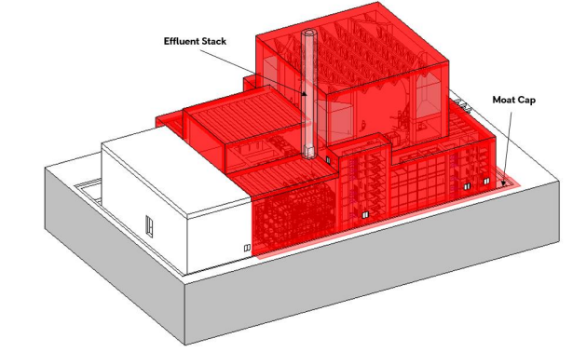

Figure 2 - Isometric arrangement of Reactor Island with Hazard Shield extents highlighted red[3] (ref. [51])

1. The hazard shield sits atop the basemat which is supported by the aseismic bearings. The hazard shield is approximately 91 m long, 61 m wide and around 50 m in height (tallest wall, excluding stack). The hazard shield is formed from reinforced concrete walls and slabs. The roof slabs are supported by a steel liner (which the RP states is permanent formwork) and steel trusses. There are internal reinforced concrete walls which provide lateral stability as well as segregation between the process clusters (Figure 9).
2. The effluent stack definition is under development. Limited details are provided in the design description (ref. [51]). I raised RQ-01293 (ref. [54]) to gain clarity and the RP confirmed that the effluent stack will be a lightweight steel structure and is expected to extend between 10 - 15 m above the roof shell.
3. There are various openings in the hazard shield for personnel, piping and other plant access (e.g. fuel handling). Design development for ensuring openings are suitably protected from missiles, impact and fire spread is ongoing; however principles and options under consideration are provided by the RP.
4. The construction methodology proposes to make use of in-situ concrete walls between pre-cast units at ‘nodal locations’ (e.g. corners). For the roof construction, permanent formwork which sits atop the steel trusses is proposed, to enable in-situ concrete pours. I consider that constructability considerations are appropriate for this stage of GDA but further information is expected in Step 3 to demonstrate adequate provision for construction as per SAP ECE.25
5. For the roof permanent formwork and trusses, further information is required to demonstrate acceptable behaviour under aircraft impact scenarios. This is a residual matter for Step 3.
6. Limited information is provided about through life examination, maintenance inspection and testing, of the hazard shield in the design description (ref. [51]) but a forward action plan commits to further work to enable access for specific hazard shield related EIMT activities.
7. The RP (ref. [70]) states that, for removal of large equipment (such as steam generators), the assumption is that they will be removed upwards through the containment vessel roof, hazard shield and the architectural covering. This appears to be confirmed by the design description (ref. [51]), which includes a forward action plan related to access to the hazard shield roof for EIMT activities, including an assumption relating to the unplanned removal of steam generators which will ‘pass through’ the hazard shield. The RP’s response to RQ-01180 (ref. [54]) infers validation will be provided in Step 3. I note that it is an explicit assumption in the design description (ref. [51]) that openings through the roof structures are minimised. If there is no specific design provision for removal of large items (e.g. a steam generator) through the hazard shell during the operating life, creating an opening in the hazard shield, and its subsequent reinstatement, would be a significant undertaking. This is a residual matter for Step 3, in consideration of SAP ECE.20.

### Aseismic bearings

1. The Rolls-Royce SMR uses seismic isolation to reduce the seismic demand to the majority of reactor island superstructures, including the reactor and spent fuel pool (the extents are shown in Figure 9). ONR recently commissioned further research into seismic isolation (ref. [71]). Whilst the use of seismic isolation for a UK nuclear power plant is a first of a kind (FOAK), they have been used in a handful of large scale PWRs and their use for conventional buildings is well established.
2. The design description of the aseismic bearings (ref. [50]) states that seismic isolation is provided between the basemat and pedestals by aseismic bearings which decouple the horizontal accelerations (as shown in Figure 8). This protects the isolated reactor island structures within [UWC] from the impacts of earthquake induced ground motions. The proposals provide isolation in the horizontal direction only.
3. Low damping rubber bearings (LDRBs) are to be used. Approximately 480 bearings are proposed, but the exact quantity and layout will depend on site specific conditions. Demonstration of the redundancy of the system, to meet the expectations of SAP EDR.4 (single failure criterion), is to be developed in Step 3. Further analysis to demonstrate no cliff edge effects are present following the loss of more than one bearing in a beyond design basis event is proposed (RQ-01228 - [ref.](https://wired.crm11.dynamics.com/main.aspx?appid=58b7bb57-c806-ec11-b6e5-00224841dad4&pagetype=entityrecord&etn=can_regulatoryqueries&id=cfa95a3c-5abf-ee11-9079-6045bdc1ed25) [54]) which should assist in demonstrating alignment with SAP EDR.2.
4. A retaining wall which surrounds the reactor island will act as a ‘stop’ to prevent excessive displacement, which could result in failure of the bearing system in beyond design basis events. The distance between the isolated structures and the retaining wall will be developed in accordance with ASCE 4-16. The RP has discussed potential consequences with their probabilistic safety analysis (PSA) team and confirmed, ‘the fragility of the [reactor island] civil structures and any SSCs within the [reactor island] will be subject to dynamic forces when the stop is impacted for those events exceeding the clearance to the stop and will need to be considered in the Seismic PSA of those events”. The RP acknowledged that this assessment will not be considered until the site specific seismic PSA.
5. The design description (ref. [50]) states an assumption that the isolation system is protected ‘from other hazards including flooding’, although further details are to be developed in Step 3. A moat cap which is attached to the hazard shield prevents aircraft fuel ingress and weather ingress. The structural form is under development and to be confirmed in Step 3 (ref. [51]).
6. Identification of potential internal hazards to the aseismic bearings are still under development (ref. [54]). This is also raised by the internal hazards assessment (ref. [72]). Demonstration that the bearings are protected from internal hazards is a residual matter for Step 3.
7. Detailed provisions for examination, maintenance, inspection and testing have not been provided (ref. [50]). I consider that will need to be demonstrated as per the intent of SAP ECE.20. I note that spatial provisions for bearing replacement and inspection have been provided (2 m in height and 0.9 m horizontal clearance), this aligns well with SAP ECE.8.
8. From my assessment, I have not identified any fundamental shortfalls in the RP’s overall approach to the use of the aseismic bearings.

### Steel modules

1. The Rolls-Royce SMR design proposes the use of ‘system modules’. These typically support various mechanical, engineering and plumbing (MEP) equipment. The benefit of this approach is that the modules can be assembled off-site and transported and installed upon delivery. This is a key feature of the Rolls-Royce SMR design that I regard as a novel approach in its application.
2. The steel modules are also referred to as ‘Mechanical Kit of Parts’ (MKoP); however the primary structure is under jurisdiction of the civil engineering topic, as clarified in RQ-01082 (ref. [54]) and is designed in accordance with civil engineering design codes including:

* AISC N690-18
* AISC 341-16
* AISC 360-16
* ASCE 7-16
* ASCE 43-19

1. Figure 3 shows the boundary between civil engineering and structural integrity components.

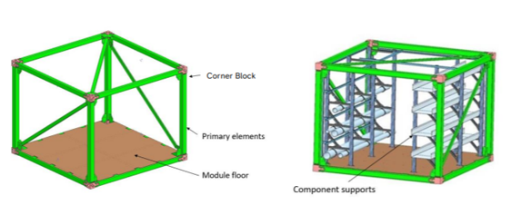

Figure 3 - Civil Engineering Scope (L), Structural Integrity Scope (R) (ref. [73])

1. I sampled the design description for the process clusters (ref [52].) which describes the design of the ‘process clusters’ within the seismically isolated reactor island. It (ref. [52]) defines a process cluster as, ‘the conglomeration of ‘system modules’ into discrete structural framing systems.’ Figure 4 shows the terminology used for module combinations. The process clusters are anchored into the concrete structure at the base of the cluster only (i.e. no lateral support from concrete walls) For each process cluster, segregation concrete walls (barriers) are provided (Figure 9, yellow lines indicate segregation walls).

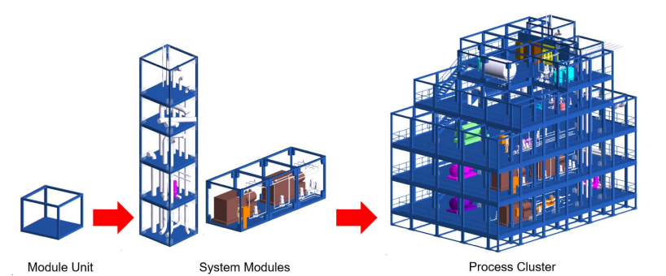

Figure 4 - Assembly of Modules, System Modules and Process Clusters[4] (ref. [52])

1. The ‘Fluids Block’ [UJT], ‘Electrical, Control and Instrumentation (EC&I) Block’ [UJS] and ‘Auxiliary Block’ [UKA10] predominantly comprise ‘process clusters’ (ref. [52]).
2. At the time of my assessment, the design is still developing. For example, the seismic force resisting system is still under development and the selection and location of internal hazards barriers within the process clusters is not confirmed. These are captured in ‘forward action plans’. The focus of my assessment has been the overall philosophy and proposed design methodology as captured in section 4.3.
3. Preliminary assessments of samples of module clusters have considered an assumed beyond design basis event of 150% of the design basis event (ref. [73]). I consider this approach to reduce design risk whilst the beyond design basis methodology is still to be developed.
4. No details are provided of the connection between the MKoP which form the process clusters and the concrete interface (ref. [52] and ref. [73]), although the latter provides an overview of current optioneering progress. It stated as an assumption in the design description for the reactor island (ref. [52]) that the connection will be cast in place and not post-installed. This meets high level ONR expectations (ref. [74]) for Class 1 structures but I note that the approach taken needs to be fully detailed and substantiated in Step 3.
5. The connection design between the constituent frames of the MKoP is still under development. The RP acknowledges (ref. [52]) that qualification may be required in accordance with AISC 341-16. I have not further sampled this topic, and note that a number of options are under consideration by the RP (ref. [73]) and it is a residual matter for consideration in Step 3.
6. The RP’s submission (ref. [73]), states:

* “As the seismic response is proportional to the mass of the structure, it is important to note that it is not possible to design a generic modular cluster that governs all future configurations. Every cluster will need to be assessed independently based on the distribution of mass within the cluster”

1. I consider this to be a positive acknowledgement in respect of the use of MKoP, and such assessments will be sampled in Step 3.
2. Further to paragraph 179, some specific systems are referred to. However, notable in its omission (ref. [52]) is the Main Control Room (MCR).
3. I have not noted any specific requirements for process clusters supporting the MCR (ref. [52]). IAEA SSR 2/1 requirement 65, ‘control room, states that adequate information shall be provided for the protection of occupants of the control room, for a protracted period of time, against hazards such as …fire’.
4. In respect of design basis fire (differentiated from life fire safety), it (ref. [52] ) states:

* ‘Design basis fire support and withstand claims are placed on segregating barriers / structures as opposed to the process clusters.’

1. This aligns with the response I received to RQ-01134 (ref. [54]), but is not consistent with the design definition (ref. [73]) which states that the bounding requirement for structural fire protection is, ‘MKoP frames shall retain structural integrity in the event of a design basis fire of duration of 4 hours’. Therefore I have identified the following:

* It is a residual matter that the RP should confirm the fire withstand of the steel process clusters. The requirements of the segregating walls, process cluster steelwork and internal ‘MKoP’ barriers should be distinguished and detailed.

1. I have identified this as an area to follow up during Step 3 with ONR’s internal hazards and life fire safety disciplines as a residual matter in Step 3. This includes sampling that the design decisions made in respect of the MCR are ALARP.
2. The design of the process clusters is still developing at this stage. However, I have sampled the design and analysis methodologies (see section 4.3) and noted some shortfalls, which are residual matters for Step 3. The adopted approach for the MCR will require robust justification and substantiation; however, this is a smaller structure and alternative options (e.g. RC) could be considered without widescale re-design. As such, I have not identified any fundamental shortfalls in the overall approach to the use of steel modular frames.

### Raft Foundation

1. The raft foundation is of typical reinforced concrete construction and supports the reactor island structures as shown in Figure 8 and Figure 9 (r). The raft foundation is 70 m x 123.2 m in plan and nominally 3 m thick, with a potentially thicker raft foundation for the Stiff Clay ground model. The bearing pedestals are supported by pre-cast frames embedded within the raft foundation.
2. Ground models for GDA assume a groundwater level at the ground surface, suggesting that dewatering or groundwater control will be required during construction. Uplift checks will be required to consider which elements of the reactor island need to be constructed before the cessation of groundwater control measures.
3. Raft foundation stiffness is important to the assessment of SSI and of settlement performance, of the raft itself, as well as for settlement relative to adjacent and connected structures. The raft foundation is described as “reasonably flexible” in the structural design method statement (ref. [45]). Section 4.3.2.2 discusses the proposed geotechnical analysis.
4. Static and seismic loads on the RI raft foundation, and performance expectations to meet functional requirements, are not yet defined. The design is expected to consider typical construction requirements, such as verification of formation conditions and protection to ensure design requirements are met.
5. The construction method of the raft foundation proposed by the RP uses prefabricated reinforcement mats and sacrificial steel frames to support the top reinforcement mat and bearing pedestals. How these frames are supported on the bottom mat, or the ground below, is not presented in detail (ref. [50]). Further information, to demonstrate the design meets the intent of SAP ECE.25, is expected in Step 3.
6. Limited details of through life EIMT activities are presented in the design description (ref. [50]), but a forward action plan confirms this will be developed. Further information, to demonstrate the design meets the intent of SAP ECE.20 is expected be provided in Step 3.
7. The seismic isolation bearing pedestals are currently proposed to be precast and manufactured offsite, and placed before pouring the raft, with anchors projecting downwards into the raft, stabilised by the steel frames used to support the reinforcement top mat.
8. Based on the information sampled in Step 2, I have not identified fundamental shortfalls with the raft foundation concept proposed by the RP.

### Containment support structure

1. I have sampled the design description (ref. [48]) which summarises the design of the containment support structure (CSS).
2. The CSS supports the containment vessel, in which the reactor pressure vessel and containment internal structures are housed. The CSS is supported by the basemat which interfaces with the aseismic bearings.
3. The CSS is reinforced concrete with a central plinth and 3 outer plinths, as shown in Figure 5. The central plinth has a diameter of 20 m and thickness varying from 0.7 m at its centre to 2.4 m at the outer edges. The width of the outer plinths is 2 m, the height was not provided but the appear to be around 6 m in height. The design of the connection between the CSS and the steel containment vessel is still under consideration by the RP, with the design and methodology to be provided in Step 3 (RQ-01231 - ref. [54]).

A diagram showing the civil engineering support structures for the containment. These include the inner plinth, which is an inverted dome to support the base, and the outer plinths, composed of three curved walls.

Figure 5 - Containment support structure comprising inner and outer plinths (ref. [48])

1. The geometry of the structure has considered a vertical clearance of 2 m to allow access for in-situ welding of the lower dome of the containment during the construction phase and for weld inspections through-life. There is clear space around the structure to allow for inspection of the vertical faces of the concrete plinths.
2. Definition of load combinations beyond ACI 349 and AISC N690 (e.g. load combinations associated with the containment vessel) are identified as future work (ref. [48]).
3. Based on the information sampled in Step 2, I consider that the design appears feasible.

### Spent fuel pool structure

1. Due to deferred submissions and layout changes which occurred late in Step 2, I carried out a limited sample of the spent fuel pool structure.
2. The spent fuel pool is within the ‘fuelling block’ shown in Figure 7 and Figure 8. The spent fuel pool is part of a wider structure which also comprises the cask loading pit and the upender pit structures (ref [53]). The response to RQ-01227 (ref. [54]) confirmed the structural form of the spent fuel pool is reinforced concrete with a stainless steel liner on the internal (water) faces for confinement and leak tightness purposes (ref. [53]). The design description (ref. [53]) states that the fuel pools leak detection and collection system will be integrated within the walls and floors of the structure, with a collection tank located on the basemat, which I consider in alignment with the expectations of SAP EMC.25.
3. The design description (ref. [53]) states that the definition of internal loads is on-going and therefore are not included. Impactive and impulsive loading methodologies are identified as future work (ref. [45]). Similarly, the spent fuel pool overhead crane support structure is future work. I note that the internal hazard assessment has assessed dropped load methodologies (ref. [72]) in Step 2. Consideration of dropped loads on civil engineering structures is a residual matter for Step 3.
4. The proposed structure is comparable with other spent fuel pools that ONR has assessed during GDA.

### Containment internal structures

1. I have not explicitly sampled the design of the containment internal structures. However, I have reviewed the methodologies applicable to the containment internal structures as part of my assessment.
2. An overview of the containment internal structures is provided in ‘Appendix 2 – Overview of the Design’. I note that the containment internal structures includes ‘module stacks’ which support systems, including the passive containment cooling system (PCCS), heat exchangers [JNK] and mechanical handling systems for RCP removal. The design description (ref. [49]) states that the maturity of the design of the module stacks is at a low maturity, but that general principles contained within the design description for process clusters is still applicable. Accessibility for EIMT activities within the containment is discussed in the mechanical engineering (ref. [75]) and conventional health and safety assessment reports (ref. [76]).
3. I have not had sufficient information in Step 2 to assess these structures to determine whether fundamental shortfalls exist in the design of the containment internal structures.

# Conclusions

## Conclusions

1. This report presents the Step 2 civil engineering assessment for the GDA of the Rolls-Royce SMR design. The focus of my assessment in this Step was towards the fundamental adequacy of the design and safety case. I have assessed the Tier 1 E3S chapters and relevant supporting documentation provided by Rolls-Royce SMR Limited to form my judgements. I targeted my assessment, in accordance with my assessment plan (ref. [14]), at the content of most relevance to civil engineering against the expectations of ONR’s SAPs, TAGs and other guidance which ONR regards as relevant good practice.
2. Based upon my assessment, I have concluded the following:

* Further work is required to present a fully developed safety case which meets UK relevant good practice. Required development of the safety case is identified in regulatory observation, ‘RO-RRSMR-001’ but specific findings from my report include: the need to provide fully defined safety functional requirements for civil engineering structures; to provide evidence of a clear and traceable golden thread from claims through to substantiation; and to provide clear evidence that the design options chosen and their subsequent design reduces risks ALARP.
* The design principles and methodologies adopted, whilst on the whole meet UK relevant good practice, require further development to demonstrate that they are sufficient to enable the design and substantiation the civil structures.
* The concept design features that were sampled include a number of aspects which are considered ‘typical’ compared with other reactor plant designs and some areas which are novel. Subject to further detailed assessment and design justification, the options are considered viable.
* A number of residual matters have been identified for consideration during Step 3. None of these has resulted in a regulatory observation, but represent areas which require clarity or development. I am satisfied that these can be addressed by Rolls-Royce SMR Limited in Step 3.

1. Overall, based on my assessment to date, and subject to the provision and assessment of suitable and sufficient supporting evidence, I have not identified any fundamental safety shortfalls that could prevent ONR permissioning the construction of a power station based on the generic Rolls-Royce SMR design.

## Recommendations

1. My recommendations are as follows:

* Recommendation 1: ONR should consider the outcomes from my assessment as part of the decision to progress to Step 3 of GDA for the generic Rolls-Royce SMR design.

# References

|  |  |
| --- | --- |
| [1] | Rolls-Royce SMR Limited, Environment, Safety, Security and Safeguards Case Version 2, Tier 1, Chapter 1: Introduction, SMR0004294, Issue 3, May 2024. (Record ref. ONRW-2019369590-9881). |
| [2] | Rolls-Royce SMR Limited, Environment, Safety, Security and Safeguards Case Version 2, Tier 1, Chapter 2: Generic Site Characteristics, SMR0004542, Issue 3, May 2024. (Record ref. ONRW-2019369590-9883). |
| [3] | Rolls-Royce SMR Limited, Environment, Safety, Security and Safeguards Case Version 2, Tier 1, Chapter 3: E3S Objectives and Design Rules for SSCs, SMR0004589, Issue 3, May 2024. (Record ref. ONRW-2019369590-9885). |
| [4] | Rolls-Royce SMR Limited, Environment, Safety, Security and Safeguards Case Version 2, Tier 1, Chapter 9B: Civil Engineering Works and Structures, SMR0003778, Issue 3, May 2024. (Record ref. ONRW-2019369590-9900). |
| [5] | Rolls-Royce SMR Limited, Environment, Safety, Security and Safeguards Case Version 2, Tier 1, Chapter 14: Plant Construction and Commissioning, SMR0004289, Issue 3, May 2024. (Record ref. 2019369590-9921). |
| [6] | Rolls-Royce SMR Limited, Environment, Safety, Security and Safeguards Case Version 2, Tier 1, Chapter 21: Decommissioning and End of Life Aspects, SMR0004599, Issue 3, May 2024. (Record ref. ONRW-2019369590-9911). |
| [7] | Rolls-Royce SMR Limited, Environment, Safety, Security and Safeguards Case Version 2, Tier 1, Chapter 22: Conventional and Fire Safety, SMR0004367, Issue 3, May 2024. (Record ref. ONRW-2019369590-9912). |
| [8] | Rolls-Royce SMR Limited, Environment, Safety, Security and Safeguards Case Version 2, Tier 1, Chapter 24: ALARP Summary, SMR0004487, Issue 3, May 2024. (Record ref. ONRW-2019369590-9914). |
| [9] | ONR, Guidance on Mechanics of Assessment, NS-TAST-GD-096, Issue 1.2, December 2022. www.onr.org.uk/media/documents/guidance/ns-tast-gd-096.docx. |
| [10] | ONR, Safety Assessment Principles for Nuclear Facilities (SAPs), 2014 Edition, Revision 1, January 2020. www.onr.org.uk/media/pobf24xm/saps2014.pdf. |
| [11] | ONR, Technical Assessment Guides. www.onr.org.uk/publications/regulatory-guidance/regulatory-assessment-and-permissioning/technical-assessment-guides-tags/nuclear-safety-tags/technical-assessment-guides-tags-nuclear-safety-full-list/. |
| [12] | ONR, Guidance on the Production of Reports for Permissioning and Assessment, NS-TAST-GD-108, Issue No. 1, December 2022. (Record ref. 2022/71935). |
| [13] | ONR, New Nuclear Power Plants: Generic Design Assessment Guidance to Requesting Parties, ONR-GDA-GD-006, Revision 0, October 2019. www.onr.org.uk/media/pylbvfnz/onr-gda-gd-006.pdf. |
| [14] | ONR, Step 2 Civil Engineering Assessment Plan for the Generic Design Assessment of the Rolls-Royce SMR, ONR-GDA-AP-22-022, Issue No. 1, March 2023. (Record ref. ONRW-2126615823-784). |
| [15] | ONR, Project Assessment Report, Generic Design Assessment of the Rolls-Royce SMR - Step 2 Summary, July 2024. (Record ref. ONRW-2019369590-8980). |
| [16] | Rolls-Royce SMR Limited, Rolls-Royce SMR Generic Design Assessment Scope, SMR0002183, Issue 2, January 2023. (Record ref. 2023/7807). |
| [17] | IAEA, Safety Standards. www.iaea.org. |
| [18] | IAEA, Nuclear Security series. www.iaea.org. |
| [19] | WENRA, Safety Reference Levels for Existing Reactors 2020. February 2021. WENRA. www.wenra.eu. |
| [20] | WENRA, WENRA Safety Objectives for New Nuclear Power Plants and WENRA Report on Safety of new NPP designs - RHWG position on need for revision. September 2020. www.wenra.eu. |
| [21] | ONR, Regulating duties to reduce risks to ALARP, NS-TAST-GD-005, Issue No. 12, January 2024. www.onr.org.uk/media/documents/guidance/ns-tast-gd-005.docx. |
| [22] | ONR, Civil Engineering, NS-TAST-GD-017, Issue 4.1, December 2022. www.onr.org.uk/operational/tech_asst_guides/ns-tast-gd-017.htm. |
| [23] | ONR, The purpose, scope and content of safety cases, NS-TAST-GD-051, Issue 7.1, December 2022. www.onr.org.uk/media/documents/guidance/ns-tast-gd-051.docx. |
| [24] | ONR, Categorisation of Safety Functions and Classification of Structures, Systems and Components, NS-TAST-GD-094, Revision 2, July 2019. www.onr.org.uk/media/documents/guidance/ns-tast-gd-094.pdf. |
| [25] | IAEA, Site Evaluation for Nuclear Installations, Specific Safety Requirements No. SSR-1, April 2019. www.iaea.org. |
| [26] | IAEA, Safety of Nuclear Power Plants: Design, Specific Safety Requirements No. SSR-2/1, Rev. 1, February 2016. www.iaea.org. |
| [27] | IAEA, Format and Content of the Safety Analysis Report for Nuclear Power Plants, Specific Safety Guide No. SSG-61, September 2021. www.iaea.org. |
| [28] | IAEA, Seismic Hazards in Site Evaluation for Nuclear Installations, Specific Safety Guide No. SSG-9, Revision 1, January 2022. www.iaea.org. |
| [29] | IAEA, Seismic Design for Nuclear Installations, Specific Safety Guide No. SSG-67, November 2021. www.iaea.org. |
| [30] | IAEA, Design of Nuclear Installations Against External Events Excluding Earthquakes, Specific Safety Guide No. SSG-68, December 2021. www.iaea.org. |
| [31] | IAEA, Safety Aspects of Nuclear Power Plants in Human Induced External Events: General Considerations. Safety Reports Series No. 86, March 2017. www.iaea.org. |
| [32] | IAEA, Safety Aspects of Nuclear Power Plants in Human Induced External Events: Assessment of Structures. Safety Reports Series No. 87, February 2018. www.iaea.org. |
| [33] | IAEA, Safety Aspects of Nuclear Power Plants In Human Induced External Events: Margin Assessment. Safety Reports Series No. 88, March 2017. www.iaea.org. |
| [34] | Rolls-Royce SMR Limited, RR SMR GB Generic Site Envelope, SMR0001535, Issue 2, June 2023. (Record ref. ONRW-2019369590-3166). |
| [35] | Arup, ONR968 – Provision of Support on Civil Engineering Safety Assessment for Step 2 of the Rolls-Royce SMR, Civil Engineering Assessment Report, ONR968-REP001, Issue 2, May 2024. (Record ref. ONRW-2126615823-3392). |
| [36] | Arup, ONR968 - Provision of Support on Civil Engineering Safety Assessment for Step 2 of GDA of the Rolls-Royce SMR, Aircraft Impact Assessment Report, ONR968-REP002, Issue 1, May 2024. (Record ref. ONRW-2126615823-3393). |
| [37] | Rolls-Royce SMR Limited, E3S Case Route Map, SMR0002155, Issue 3, November 2023. (Record ref. ONRW-2126615823-1777). |
| [38] | Rolls-Royce SMR Limited, Overview of RR SMR Civil Engineering Structures, SMR0005684, Issue 2, January 2024. (Record ref. ONRW-2019369590-6538). |
| [39] | Rolls-Royce SMR Limited, Design Basis for Reactor Island Structures, SMR0005690, Issue 2, November 2023. (Record ref. ONRW-2019369590-5261). |
| [40] | Rolls-Royce SMR Limited, Design Basis for Back-up Generation Structures, SMR0005691, Issue 2, November 2023. (Record ref. ONRW-2019369590-5262). |
| [41] | Rolls-Royce SMR Limited, Design Basis for Essential Services Water System (ESWS) Structures, SMR0005692, Issue 2, November 2023. (Record ref. ONRW-2019369590-5257). |
| [42] | Rolls-Royce SMR Limited, Civil and Structural Codes and Standards Policy, SMR0006030, Issue 1, June 2023. (Record ref. ONRW-2019369590-3240). |
| [43] | Rolls-Royce SMR Limited, Material Code Compliance, SMR0001130, Issue 2, June 2023. (Record ref. ONRW-2019369590-3241). |
| [44] | Rolls-Royce SMR Limited, Generic Design Parameters for Civil Engineering, SMR0006070, Issue 2, November 2023. (Record ref. ONRW-2019369590-5130). |
| [45] | Rolls-Royce SMR Limited, Structural Design Method Statement, SMR0005708, Issue 2, November 2023. (Record Ref. ONRW-2019369590-5259). |
| [46] | Rolls-Royce SMR Limited, Aircraft Impact Design Philosophy and Methodology Statement, SMR0005709, Issue 2, November 2023. (Record ref. ONRW-2019369590-5258). |
| [47] | Rolls-Royce SMR Limited, Design Description for Back-Up Generation Structures, SMR0005706, Issue 1, December 2023. (Record ref. ONRW-2019369590-5804). |
| [48] | Rolls-Royce SMR Limited, Design Description for Reactor Island - Basemat and Containment Support Structure, SMR0005700 , Issue 1, January 2024. (Record ref. ONRW-2019369590-5806 ). |
| [49] | Rolls-Royce SMR Limited, Design Description for Reactor Island - Containment Internal Structures, SMR0005696, Issue 1, January 2024. (Record ref. ONRW-2019369590-6539). |
| [50] | Rolls-Royce SMR Limited, Design Description for Reactor Island - Foundation and Seismic Isolation System Structures, SMR0005704, Issue 1, December 2023. (Record ref. ONRW-2019369590-5805). |
| [51] | Rolls-Royce SMR Limited, Design Description for Reactor Island - Hazard Shield, SMR0005701, Issue , January 2024. (Record ref. ONRW-2019369590-6540). |
| [52] | Rolls-Royce SMR Limited, Design Description for Reactor Island - Process Clusters, SMR0005698, Issue 1, January 2024. (Record ref. ONRW-2019369590-6541). |
| [53] | Rolls-Royce SMR Limited, Design Description for Reactor Island – Fuelling Block, SMR0005699, Issue 1, January 2024. (Record ref. ONRW-2019369590-6537). |
| [54] | ONR, Schedule of Step 2 Regulatory Queries, April 2024. (Record ref. ONRW-2019369590-9071). |
| [55] | Rolls-Royce SMR Limited, Rolls-Royce SMR Maturity Status of SSCs, SMR0007438, Issue 1, August 2023. (Record ref. ONRW-2019369590-3805). |
| [56] | Rolls-Royce SMR Limited, Rolls-Royce SMR – GDA Design Reference Report, SMR0009043, Issue 2, April 2024. (Record ref. ONRW-2019369590-8872). |
| [57] | Rolls-Royce SMR Limited, Rolls-Royce Small Modular Reactor Seismic Performance Classification Method, SMR0001391, Issue 2, October 2022. (Record ref. 2022/63716)​. |
| [58] | Rolls-Royce SMR Limited, Rolls-Royce SMR Environment, Safety, Security and Safeguards Categorisation and Classification Method, SMR0006518, Issue 1, July 2023. (Record ref. ONRW-2019369590-3688). |
| [59] | ONR, Regulatory Observation - Development of the generic E3S case, RO-RRSMR-001, Revision 0, August 2023. www.onr.org.uk/media/k0odfpcf/ro-rrsmr-001.docx. |
| [60] | ONR, Generic Design Assessment of the Rolls-Royce SMR - Step 2 assessment of External Hazards, ONRW-2126615823-3584, Issue No. 1, June 2024. (Record ref. ONRW-2126615823-3584). |
| [61] | U.S.NRC, Technical Considerations for Seismic Isolation of Nuclear Facilities, NUREG/CR-7253, February 2019. www.nrc.gov. |
| [62] | IAEA, Site Survey and Site Selection for Nuclear Installations, Specific Safety Guide No. SSG-35, July 2015. www.iaea.org. |
| [63] | ONR, External Hazards, NS-TAST-GD-013, Issue 9, October 2023. www.onr.org.uk/publications/regulatory-guidance/regulatory-assessment-and-permissioning/technical-assessment-guides-tags/nuclear-safety-tags/ns-tast-gd-013-external-hazards/. |
| [64] | ONR, New Nuclear Power Plants: Generic Design Assessment Technical Guidance, ONR-GDA-GD-007, Revision 0, May 2019. www.onr.org.uk/media/c2delysl/onr-gda-007.pdf. |
| [65] | SNC-Lavalin, UK Small Modular Reactor Geotechnical Design Parameters, SMR-SNC-G01-XX-RA-4G-0001, Rev. 1, May 2020. (Record ref. ONRW-2019369590-6176). |
| [66] | ONR, Malicious Aircraft Impact - UK Expectations, Letter sent 27 November 2023. (Record ref. ONRW:2019369590-5263). |
| [67] | Nuclear Energy Institute, NEI 07-13 Methodology for Performing Aircraft Impact Assessment for New Plant Designs, Revision 8, April 2011. www.nrc.gov. |
| [68] | ONR, Contact Record - Discussions on Aircraft Impact Threat Definition Meeting - 6 December 2023, ONR-NR-CR-23-476, Rev. 1, 21st December 2023. (Record ref. ONRW-2019369590-5909). |
| [69] | Rolls-Royce SMR Limited, Aircraft Impact Hazard Definition Report, SMR0005695, Issue 1, January 2024. |
| [70] | Rolls-Royce SMR Limited, Reactor Island Mechanical Handling Design Summary Report, SMR0008622, Issue 1, November 2023. (Record ref. ONRW-2019369590-5422). |
| [71] | Arup, Independent Research into the Seismic Isolation of SMRs and AMRs, 292732-02-ONR895-REP001, September 2023. www.onr.org.uk/our-expertise/research/. |
| [72] | ONR, Generic Design Assessment of the Rolls-Royce SMR - Step 2 assessment of Internal Hazards, ONRW-2126615823-3464, Issue No. 1, June 2024. (Record ref. ONRW-2126615823-3464). |
| [73] | Rolls-Royce SMR Limited, Modularisation Kit of Parts Primary Structure Standard Frame Design Definition, SMR0008277, Issue 2, January 2024. (Record ref. ONRW-2019369590-7009). |
| [74] | ONR, ONR-CEEH-LTT-003 LTT on Fixings into Structural Concrete, Version 7, November 2023. (Record ref. 2023/61153). |
| [75] | ONR, Generic Design Assessment of the Rolls-Royce SMR - Step 2 assessment of Mechanical Engineering, ONRW-2126615823-3642, Issue No. 1, June 2024. (Record ref. ONRW-2126615823-3642). |
| [76] | ONR, Generic Design Assessment of the Rolls-Royce SMR - Step 2 assessment of Conventional Health and Safety, ONRW-2126615823-3662, Issue No. 1, June 2024. (Record ref. ONRW-2126615823-3662). |
| [77] | Department of Energy and Climate Change, National Policy Statement for Nuclear Power Generation (EN-6), Volume I of II, July 2011. www.gov.uk. |

# Appendix 1 – Relevant SAPs considered during the assessment

|  |  |
| --- | --- |
| SAP No. | SAP Title |
| ECE.1 | Engineering principles: civil engineering - Functional performance |
| ECE.2 | Engineering principles: civil engineering - Independent arguments |
| ECE.6 | Engineering principles: civil engineering: design - Loadings |
| ECE.7 | Engineering principles: civil engineering: design - Foundations |
| ECE.8 | Engineering principles: civil engineering: design - Inspectability |
| ECE.12 | Engineering principles: civil engineering: structural analysis  and model testing - Structural analysis and model testing |
| ECE.13 | Engineering principles: civil engineering: structural analysis  and model testing - Use of data |
| ECE.14 | Engineering principles: civil engineering: structural analysis  and model testing - Sensitivity studies |
| ECE.15 | Engineering principles: civil engineering: structural analysis  and model testing - Validation of methods |
| ECE.20 | Engineering principles: civil engineering: in-service inspection and testing - Inspection, testing and monitoring |
| ECE.25 | Engineering principles: civil engineering: design - Provision for construction |
| ECE.26 | Engineering principles: civil engineering: design - Provision for decommissioning |
| EHA.4 | Engineering principles: external and internal hazards - Frequency of initiating event |
| EHA.6 | Engineering principles: external and internal hazards - Analysis |
| EHA.7 | Engineering principles: external and internal hazards - ‘Cliff-edge’ effects |
| EHA.8 | Engineering principles: external and internal hazards - Aircraft crash |
| EHA.18 | Engineering principles: external and internal hazards - Beyond design basis events |
| FA.5 | Fault analysis: design basis analysis - Initiating faults |
| EMC.25 | Engineering principles: integrity of metal components and structures: monitoring - Leakage |
| ECS.2 | Engineering principles: safety classification and standards - Safety classification of structures, systems and components |
| ECS.3 | Engineering principles: safety classification and standards - Codes and standards |
| EDR.2 | Engineering principles: design for reliability - Redundancy, diversity and segregation |
| EDR.4 | Engineering principles: design for reliability - Single failure criterion |
| ERL.1 | Engineering principles: reliability claims - Form of claims |

# Appendix 2 – Overview of the design

## High level overview

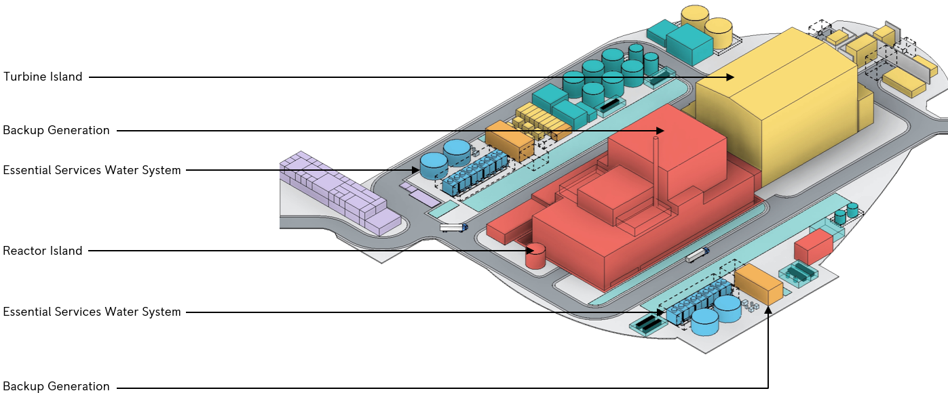

Figure 6 -Indicative Rolls-Royce SMR Layout (Cooling water island, earth berm and roof shell structure not shown) (ref. [39])

The Reactor Island includes the Structures, Systems and Components (SSCs) that form the reactor, transfer and storage of new and used fuel, and associated nuclear auxiliary systems. More detail on the reactor island is provided in this appendix, as it was subject to my targeted assessment.

The Turbine Island is located adjacent to the Reactor Island and contains the primary turbine equipment (the steam turbine and generator arrangement). Generated electricity is passed to the Transmission Area and subsequently the Grid Connection.

The Cooling Water Island provides the primary means of removing heat from the power station, passing it to the ultimate heat sink.

The Balance of Plant is located around the periphery of the site and comprises a range of support functions to the rest of the plant. This includes the provision of chemicals, utilities, water and sampling services, and general storage areas.

Back-up Generators (BUGS) provide backup power to plant systems if normal power sources are interrupted.

The Essential Services Water System (ESWS) cools hot water from the Component Cooling System located within Reactor Island.

A landscaped berm is provided around the perimeter of the SMR site. A shell structure encompasses both the Reactor and Turbine Islands.

A summary of civil engineering SSC classification is provided in Table 1.

Table 1 - Summary of Categorisation and Classification of civil structures

|  |  |  |  |  |
| --- | --- | --- | --- | --- |
| Structure [system code] | Safety Category | Safety Class | Seismic Performance Class | References |
| Hazard Shield [UWD] | A | 1 | 1 | [39] [51] |
| Basemat [UWD] | A | 1 | 1 | [39] [48] |
| Containment Support Structure [UWD] | A | 1 | 1 | [39] [48] |
| Reactor Island Foundation [UWC] | A | 1 | 1 | [50] |
| Reactor Island Retaining Wall [UWC] | A | 1 | 1 | [50] |
| Reactor Island Anti-Seismic Bearings [UWC] | A | 1 | 1 | [50] |
| Safeguards Block[5] | A | 1 | 1 | [39] |
| Fuelling Block | A | 1 | 1 | [39] |
| Ancillary Block | C | 3 | 3 | [39] |
| Auxiliary Block | B | 1 or 2 | 1 or 2 | [39] |
| Access Block | C | 3 | 3 | [39] |
| Interspace | A | 1 | 1 | [39] |
| Containment Internal Structures [UJA] | A | 1 | 1 | [39] |
| BUGS Structures [UBM] | B | 2 | 1 | [40] |
| ESWS Structures [UPJ] | B | 2 | 1 | [41] |

## Reactor Island

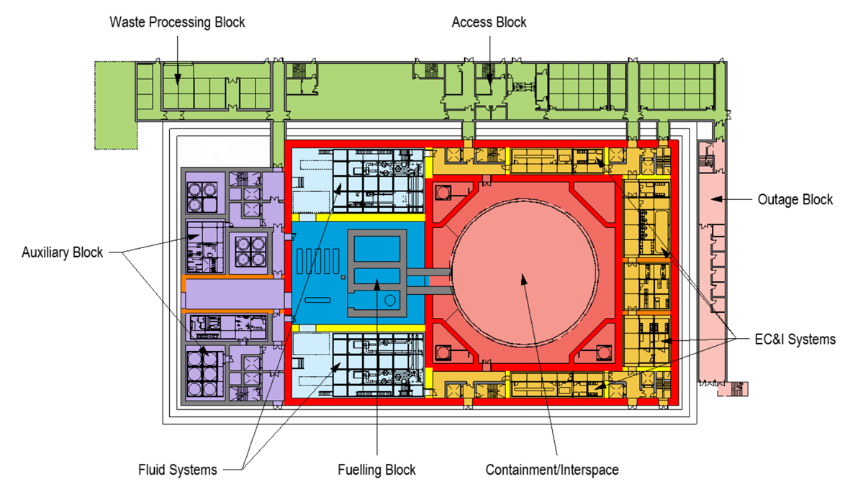

Figure 7 - Plan of Reactor Island (ref. [4])

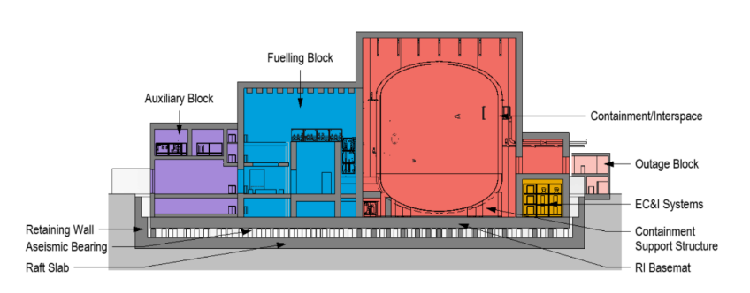

Figure 8 - Indicative Section Through Reactor Island Structures (ref. [4])

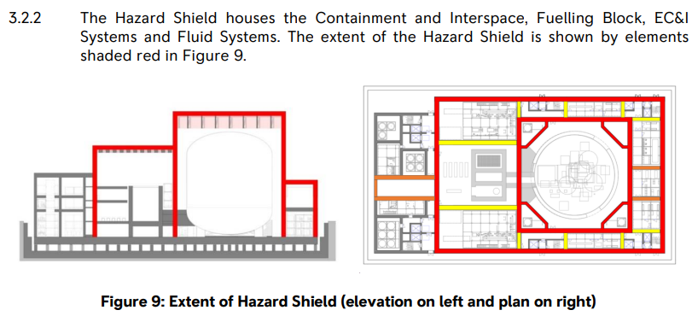

Figure 9 - Extent of hazard shield shown in red (elevation on left (l), plan on right (r)), the seismic isolation system covers all structures shown here (ref. [51])

Figure 7 shows the areas which comprise the reactor island. Figure 8 shows a section through the reactor island. Much of the reactor island is contained within the ‘hazard shield’ and supported by the aseismic bearings. A retaining wall surrounds the isolated reactor island extents as shown in Figure 8 and Figure 9. The outage, access and waste processing block are not within the extents of the retaining wall and are not seismically isolated; these structures sit at a higher elevation as shown by the outage block in Figure 8.

Figure 9 shows the extents of the hazard shield which houses the containment, interspace, fuelling block, EC&I systems and fluid systems. The reactor pressure vessel is located within the containment. The spent fuel pool is located outside the containment but within the seismically isolated island (within the fluids block).

As shown in Figure 9, the auxiliary block is outside the hazard shield extents (but still seismically isolated).

An architectural roof covers the reactor island. Further details of this were not provided during Step 2.

The seismic isolation system is supported from the reinforced-concrete (RC) raft foundation and comprises a series of RC pedestals and aseismic bearings which support an RC basemat as shown in Figure 8. This RC basemat in turn supports all other structures and SSCs located on the seismically isolated aspects of the reactor island including a direct interface with the reactor containment support structure. Stacks of steel modules which house various SSCs, termed ‘process clusters’ are anchored into the basemat (see section 4.4.3 for further details on these).

The containment vessel itself is a steel vessel, and as such is within remit of the ONR structural integrity discipline. The containment support structure (see section 4.4.5) and containment internal structures (see section 4.4.7) are within the civil engineering remit. Figure 10 provides a view of the containment internal structures. They include a reinforced concrete lower dome, which forms the reactor pressure vessel (RPV) cavity, as well as various steel and concrete upper structures providing support to various items of plant and equipment. Key systems supported by the reactor internal structures include:

* Reactor pressure vessel
* Steam generator with integral reactor coolant pump
* Pressuriser
* Refuelling cavity
* Refuelling pool
* Main overhead crane
* Fuel handling machine

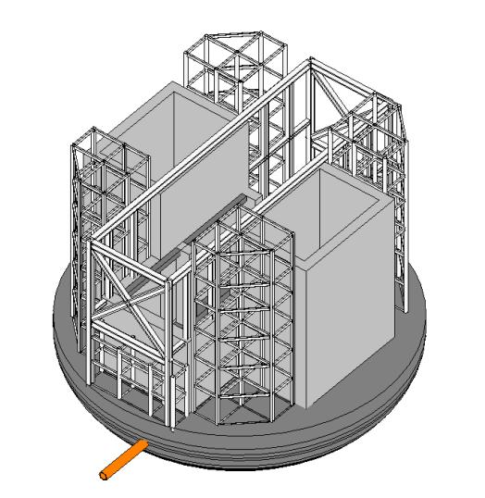

Figure 10 - Overview of containment internal structures (ref. [49])

# Appendix 3 – Seismic performance classification method flowchart

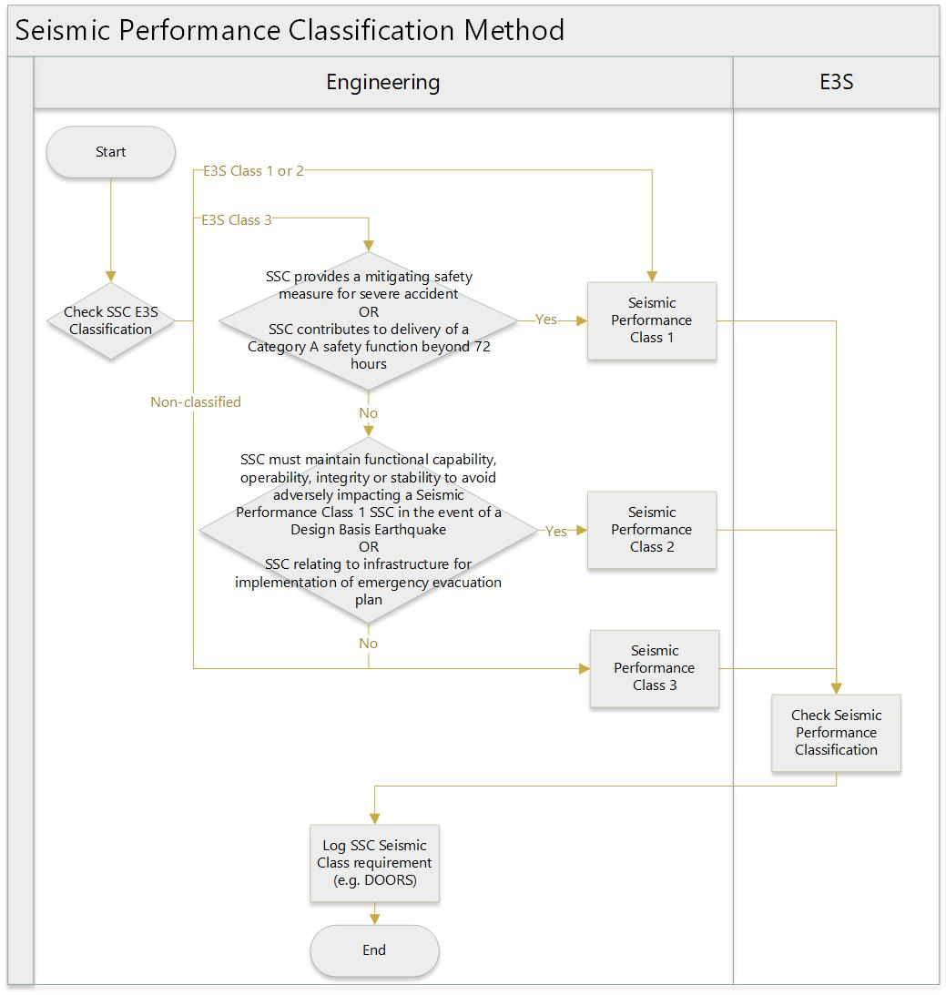

Figure 11 - Seismic Performance Classification Process Flowchart (ref. [57])

# Appendix 4 – Civil engineering document map

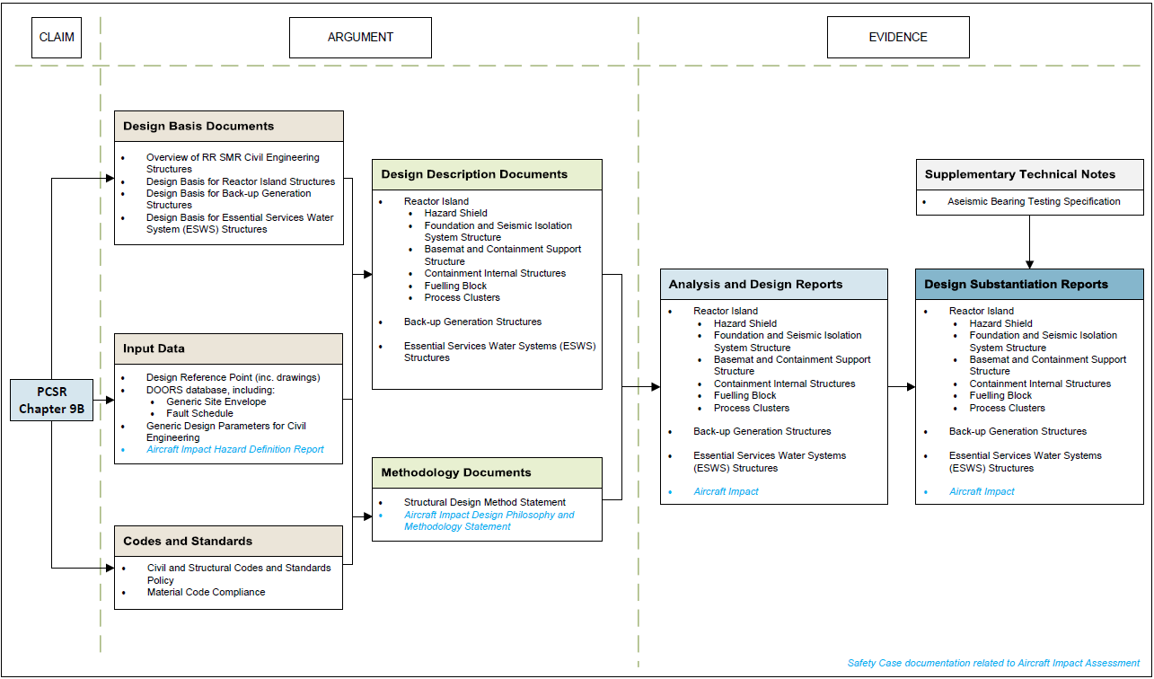

(ref. [38])

1. Naming convention based on a previous layout iteration, Safeguards Block has been replaced by Fluid Systems and EC&I Systems, refer to Figure 7.
2. UK sites refers to the EN-6 sites as defined ref. [77] and sites stated in the RP’s refs. [65] and [34]
3. The design of the effluent stack is currently under development and not discussed in this report
4. Illustrative
5. Naming convention based on a previous layout iteration, Safeguards Block has been replaced by Fluid Systems and EC&I Systems, refer to Figure 7